EXPRESS DEVELOPMENT APPLICATION REPORT FOR Reconfiruing a lot (code assessment) for two lot freehold subdivision at 17 Courtney Drive, Upper Coomera– division ##

File NO City Officer use

- PRE-SUBMISSION
Pre-submission application number | City Officer use

- APPLICATION SUMMARY
Application information
Address | 17 Courtney Drive, Upper Coomera
Lot and plan | Lot 182 on RP156422
Site area | 33,410m²
Properly made date | City Officer use
City Plan version | City Plan version 8
Zone / Precinct | Rural Residential Zone
Overlays | - Airport environs - Procedures for Air Navigation Services, Aircraft Operational (PANS-OPS) surfaces.  - Bushfire hazard area.  - Dwelling house overlay area.  - Environmental significance –priority species Matters of state environmental significance and Koala habitat areas (building envelope outside of overlay)  - Environmental significance – wetlands and waterways.  - Landslide hazard overlay (building envelope outside of overlay)
Type of development and proposed use | Reconfiguring a Lot for two lot freehold subdivision
Categories of development and assessment | Code assessment
Applicant and Applicant’s consultancy team | MO CHEN and YING YUAN– Applicant  Elevate Development Solutions Pty Ltd– Town Planning  Trilogy – Survey and Subdivision Plan  Taylor Environmental – Effluent Management  Eldon Botcher Architects – Bushfire Management  Natura Consulting – Ecological Assessment
Land owner | MO CHEN and YING YUAN
Decision due date | City Officer use
Officer’s recommendation | City Officer use

- PROPOSAL
The purpose of this report is to assess an application for a development permit for reconfiguring a lot (code assessment) for a two-lot freehold subdivision at 17 Courtney Drive, Upper Coomera.
The applicant is seeking to subdivide Lot 182 on RP156422 into two lots, with both proposed lots meeting or above the minimum lot size of 4,000m². The existing Dwelling house and Vehicle cross over are proposed to be retained for the existing dwelling. A new crossover will service the new lot.
Table 5.6: 'Reconfiguring a lot’, of the City Plan categorises the proposal as subject to code assessment because it complies with the below criteria:
• Minimum Lot Size –minimum lot area of 4,000m² and average of 8,000m2
The development key details of the proposal are outlined in the table below:
Key details for the Reconfiguring a lot development
Lot sizes | Lot 1 – 1.809 ha  Lot 2 – 1.531 ha
Road access | Lot 1 – existing crossover from Courtney Drive  Lot 2 – new crossover from Courtney Drive or Baileys Mountain Road.
Frontage | Lot 1 – 98m to Courtney Drive  Lot 2 – 129m to Baileys Mountain Road and 173m to Courtney Drive
Water | Lot 1 – existing private water storage retained.  Lot 2 – proposed new private water storage to be built within proposed development envelope.
Sewer | Lot 1 – existing private septic retained.  Lot 2 – proposed private septic to be built within proposed development envelope.
Vegetation | The proposed building envelope provides a 10m or more offset from all trees to avoid as of right clearing.
The following subdivision plan provides an initial view of the proposed development.
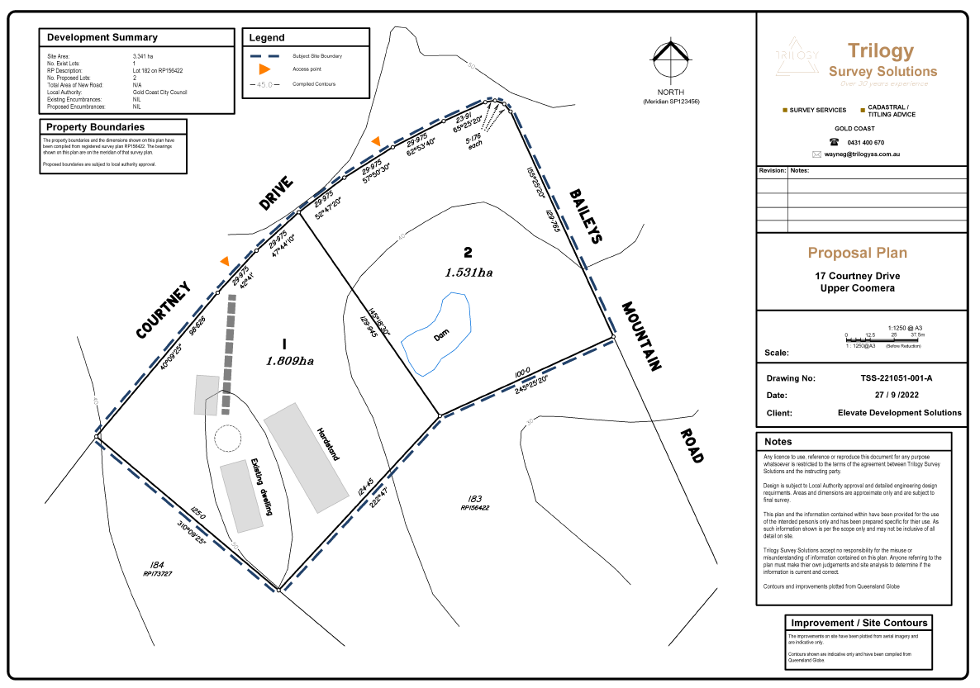
Figure 1: Proposed subdivision plan (source: Trilogy Survey Solutions)

- SITE CONTEXT
  - Subject site and immediate context
The subject site is located at the corner of Courtney Drive and Baileys Mountain Road, Upper Coomera. The site is improved with a single storey dwelling and a driveway from Courtney Drive.
An aerial of the subject site is included below:
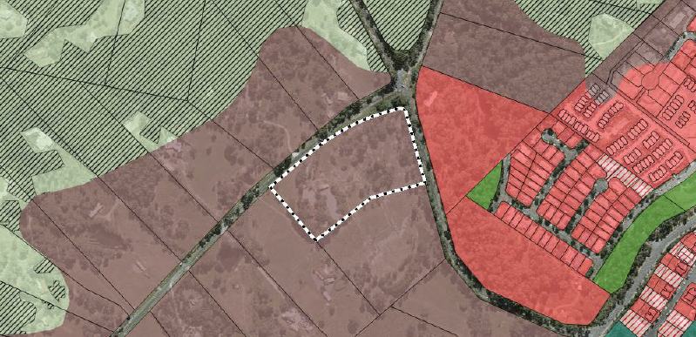
SITE
The subject site is:
- Legally described as Lot 182 on RP156422
- Currently improved by a single level Dwelling house.
- Located on a corner block fronting Courtney Drive and Baileys Mountain Road.
- Not encumbered by any easements or encumbrances.
- Site is embellished by assessable vegetation. There is no vegetation removal proposed.
- Located within the Urban Footprint of the Southeast Queensland Regional Plan 2017 (ShapingSEQ).
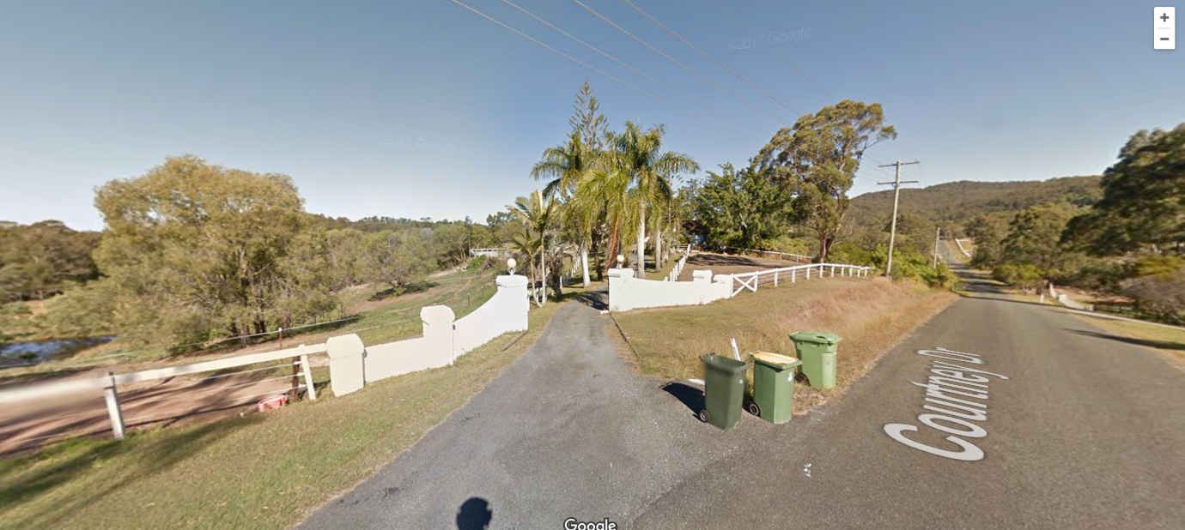
Figure 2: Subject site from Courtney Drive with existing dwelling

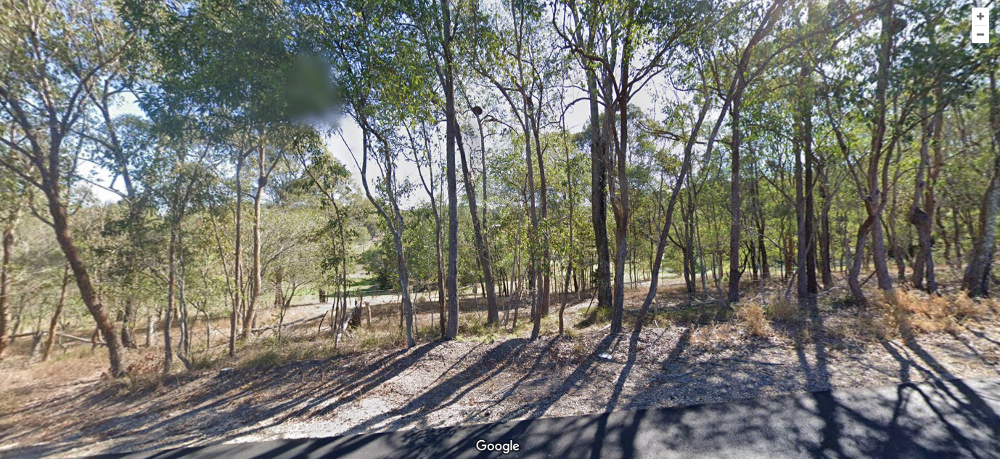

Figure 3: Subject site from Baileys Mountain Road.

- ASSESSMENT
Section 45(3) of the Planning Act 2016 identifies:
(3) A code assessment is an assessment that must be carried out only –
(a) against the assessment benchmarks in a categorising instrument for the development; and
(b) having regard to any matters prescribed by regulation for this paragraph.
The proposed development triggers code assessment and has been assessed in accordance with Section 45(3) of the Planning Act 2016.
  - State Planning instruments
The application has been assessed against the following instruments:
Instrument | Comment
State Planning Policy | The City Plan appropriately reflects all aspects of the State Planning Policy apart from aspects relating to natural hazards, risk and resilience (coastal hazards).  The proposal does not trigger assessment against any assessment benchmarks relating to natural hazards, risk and resilience (coastal hazards).
South East Queensland Regional Plan | The proposal is consistent with the goals, elements and strategies; and the Southern Sub-regional directions of the South East Queensland Regional Plan 2017 (ShapingSEQ).
Planning Regulation 2017 | The proposal does not trigger assessment against any assessment benchmarks listed in a Schedule of the Planning Regulation 2017.
Schedule 12 (Particular reconfiguring a lot requiring code assessment) of the Planning Regulation 2017 | The proposal does not trigger assessment against any assessment benchmarks in Schedule 12 (Particular reconfiguring a lot requiring code assessment) of the Planning Regulation 2017.

City Plan
The following is an assessment of the application against the City Plan.

Strategic framework
The proposal is code assessment and does not trigger assessment against the strategic framework.
The Planning Act 2016 requires codes assessable development (bounded assessment) to be carried out only against the assessment benchmarks stated in the categorising instrument (City Plan) and have regard to matters prescribed by the regulation.
Section 43 (2) (c) of the Planning Act 2016 states for code assessment, a strategic outcome (strategic framework) is not an assessment benchmark.
5.3.2 Zone
The site is located within the Rural residential zone.
“The purpose of the Rural residential zone code is to provide for residential development on large lots where local government infrastructure and services may not be provided on the basis that the intensity of residential development is generally dispersed.”
The proposal is for a two-lot freehold subdivision and subject to meeting the outcomes of the zone code, is an envisaged development for the zone.
The subdivision is concluded as appropriate for the following reasons:
- Provides a practical shaped new lot for a future dwelling house, that features a proposed development envelope that is located outside of environmental significance overlay code and landslide hazard overlay code.
- There is no vegetation lost with the proposed envelope being offset 10m from existing trees.
- Provides a new lot that meets the minimum lot size for the site and promotes a large lot that recognises the site’s inherent values, constraints and character and supports very low density.
- The reconfiguring a lot supports the outcomes for the zone and is sensitive to the environment, topography, and landscape features.
- The proposed lots are designed to effectively facilitate separate freehold allotments.
- The lot designs protect the amenity of adjacent residences.
- The lots will visually integrate with the character of the locality.
- The lots provide adequate space for landscaping along street frontages.
- Despite lack of access to local government services and facilities the proposed development will be self-reliant with electrical reticulation, telecommunications, pedestrian and vehicle access, and car parking.
- Independent private water storage will be created for the new freehold lot.
The proposal is for a two-lot freehold subdivision is an envisaged development for the zone. Based on the above assessment it is considered the development complies with the intent of the Rural Residential Zone code.
    - Assessment against the codes
Under the City Plan, compliance with a code can be achieved by either compliance with the purpose and overall outcomes of the code, or, compliance with either the performance outcomes or acceptable outcomes. Acceptable outcomes are generally quantifiable provisions, with the performance and overall outcomes generally qualitative and performance based.
The tables of assessment in Part 5 of City Plan identify the applicable assessment benchmarks for the proposal outlined in the table below:
Zone code | Overlay codes | Development codes
- Rural Residential Zone code | - Airport and Environs.  - Bushfire hazard.  - Environmental significance.  - Landslide Hazard. | - Reconfiguring a lot code  - General development provisions code  - Healthy Waters Code  - On-site Sewerage Facilities Code

This is a ‘report by exception’ and only discusses issues where the development does not meet the relevant acceptable outcomes or where a relevant performance outcome does not have a stated corresponding acceptable outcome. This is outlined in the table below:

Code | Acceptable / Performance Outcome | Subject matter
General development provisions code | PO2 | Amenity protection
Reconfiguring of a Lot | PO5 | Infrastructure

      - Assessment against the Rural residential zone code
The development is considered to meet the assessment benchmarks of the zone code.
5.3.2.2 Assessment against the overlay codes
The development is considered to meet the assessment benchmarks of all overlay codes. This is discussed below.
Bushfire Hazard Overlay Code
The site is subject to a Medium hazard and Potential bushfire impact buffer as designated by City Plan mapping. The applicant has provided a Bushfire Management Report as part of the application material. The Bushfire Assessment submitted confirms that the proposed development meets the relevant provisions of the Bushfire hazard overlay code.
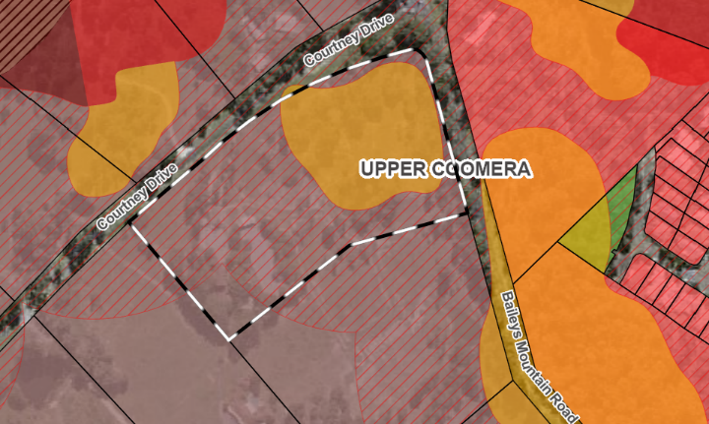

Landslide Hazard Overlay Code
The site is subject to a Moderate landslide hazard as designated by City Plan mapping. The building envelope is outside of this hazard zone. Therefore, it is concluded that the proposed subdivision achieves the relevant provisions of the Landslide hazard overlay code.
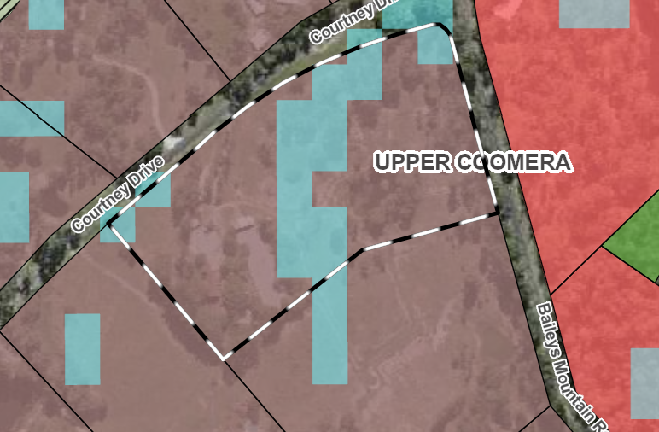

Environmental Significance Overlay Code
The site is subject to the environmental significance within the west of the property as designated by City Plan mapping. The building envelope is outside of this zone. Therefore, it is concluded that the proposed subdivision achieves the relevant provisions of the Environmental Significance Overlay Code.
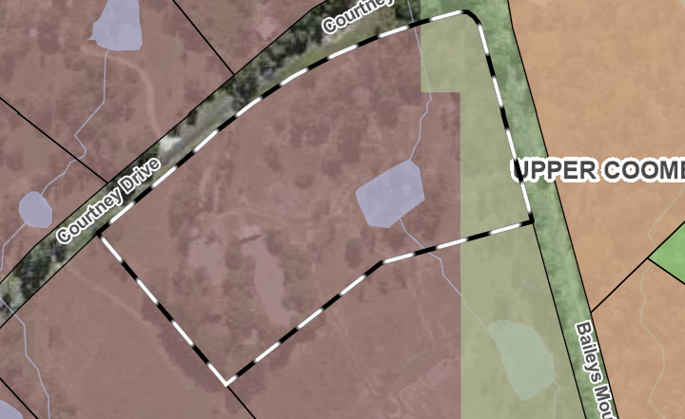

Assessment against development codes
Assessment has been undertaken against the applicable Performance outcome or Overall outcome and Purpose for each subject matter as follows:
Amenity Protection – General development provisions code

The Acceptable outcome and corresponding Performance outcome is provided below:

Performance outcome | Acceptable outcome
PO2  The proposed development prevents loss of amenity and threats to health and safety, having regard to:  - noise;  - hours of operation;  - traffic;  - signage;  - visual amenity;  - wind effects;  - privacy;  - vibration;  - contaminating substances;  - hazardous chemicals;  - odour and emissions; and  - safety. | AO2  No acceptable outcome provided.

It is considered that the proposed development demonstrates compliance with the requirements of Performance outcome (PO2). The subdivision will not have an unreasonable impact on amenity. The following comments are provided:
- Noise – Not applicable.
- Hours of operation – Not applicable.
- Traffic – The development does not present an unreasonable increase of traffic to the area
- Signage – Signage is not proposed as part of the development application.
- Visual amenity – No change to the existing development.
- Wind effects – Not applicable.
- Privacy – Not applicable.
- Vibration – Not applicable.
- Contaminating substances – The proposed development will not cause any unreasonable impacts from contaminating substances.
- Hazardous chemicals – The proposed development will not cause any unreasonable impacts from hazardous chemicals.
- Odour and emissions – The proposed development will not cause any unreasonable impacts from odour and emissions.
- Safety – The common boundary for the proposed subdivision is appropriately located to ensure existing vehicular crossings achieve minimum separation distance requirements.
Based on the above assessment it is considered the development complies with Performance outcome PO2 of the General development provisions code.
Infrastructure – Reconfiguration of a Lot Code

The Acceptable outcome and corresponding Performance outcome is provided below:

Performance outcome | Acceptable outcome
PO5  New lots are created with provision of essential services and public utilities, including sewerage, water, electricity and communication services that are designed and located to:  - meet the needs of users;  - enhance the health, safety and convenience of the community;  - be cost effective over their life-cycle;  - minimise adverse impacts to the environment (including the amenity of the local area);  - minimise risk of failure or damage during a natural hazard event; and  - support connection to fibre telecommunication infrastructure.
  AO5.1
  All lots are connected to electricity supply and telecommunications services, with the telecommunications infrastructure designed to support connection to fibre telecommunications infrastructure.
  AO5.2
  Electricity supply and telecommunications infrastructure are provided underground, where the development involves the creation of more than five lots, five dwellings, or five tenancies, except in the Rural zone.
  AO5.3
  All new lots within the Local government infrastructure plan boundary are connected to reticulated water supply in accordance with SC6.11 City Plan policy – Land development guidelines, Section 6 – Water supply and sewerage reticulation standards, except in the Extractive industry, Rural and Conservation zones.
  AO5.4
  All new lots within the Local government infrastructure plan boundary are connected to reticulated sewerage in accordance with SC6.11 City Plan policy – Land development guidelines, Section 6 – Water supply and sewerage reticulation standards, except in the Extractive industry, Rural and Conservation zones, and those lands within the Rural residential zone unless specifically stated in the Rural residential zone code.
  AO5.5
  On-site water supply is provided in accordance with SC6.11 City Plan policy – Land development guidelines, Section 6 – Water supply and sewerage reticulation standards for all new lots created in the Extractive industry, Rural, Rural residential and Conservation zones or in areas outside the Local government infrastructure plan boundary.
  AO5.6
  On-site sewage disposal is provided in accordance with Council's Guidelines for the Installation and Operation of Aerobic Wastewater Treatment Plants for Domestic and Small Scale Commercial Users 1995 and AS1547 for all new lots created in the Extractive industry, Rural, Rural residential and Conservation zones or in areas outside the Local government infrastructure plan boundary.

It is considered that the proposed development demonstrates compliance with the requirements of Performance outcome (PO5). The following comments are provided:
- The needs of the users – The proposed development will meet the needs of the users by providing the required infrastructure
- Enhance the health, safety and convenience of the community – Not applicable.
- Be cost-effective over their life-cycle – The proposed development will provide infrastructure that are cost-effective over their life-cycle.
- Minimise adverse impacts to the environment (including the amenity of the local area) – The proposed development will not cause any unreasonable impacts on the environment or amenity of the local area.
- Minimise risk of failure or damage during a natural hazard event – The proposed development will minimise any unreasonable impacts on infrastructure caused by a natural hazard event.
- Support connection to fibre telecommunication infrastructure – Not applicable.

Based on the above assessment it is considered the development complies with Performance outcome PO5 of the Reconfiguring a lot code.

Healthy Waters Code
Review of the above code has been carried out and is provided within Attachments. The review of the Code shows that the proposed development satisfies all applicable Performance and/or Acceptable outcomes of the Code.

On-site Sewerage Facilities Code

The subject site is unsewered and therefore the applicant has provided an Effluent Disposal Report as part of the application material. The Effluent report submitted confirms that the proposed development meets the relevant provisions of the above code. Review of the above code has been carried out and is provided within Attachments. The review of the Code shows that the proposed development satisfies all applicable Performance and/or Acceptable outcomes of the Code.

- INFRASTRUCTURE CHARGES City Officer use
The final estimated infrastructure charge is insert details.
City officer to insert extract of infrastructure charges notice
- REFERRALS City Officer use
7.1 Internal referrals
This application has been assessed by internal referral officers who have provided comments and reasonable and relevant conditions, identified below.
Internal referral area | Conditions/Comments (if not included within report)
Hydraulics and Water Quality
Plumbing and Drainage
Subdivision Engineering
Water and Waste

8 CONCLUSION

The purpose of this report was to assess an application for a development permit for reconfiguring a lot (code assessment) for a two-lot freehold subdivision.
After a detailed assessment, it has been determined the proposal complies with all the applicable assessment benchmarks for the proposal or can be conditioned to comply with all the applicable assessment benchmarks for the proposal.
It is recommended the application be approved, subject to conditions.
City Officer use
It is recommended the application be approved, subject to conditions.
- NOTIFICATIONS City Officer use
The following property notifications will be applied:
- Flood Covenant

- RECOMMENDATION City Officer use
It is recommended that Council resolves as follows:
That under Delegated Authority, the Executive Coordinator Planning Assessment of City Development approves (with conditions) the issue of a development permit for a material change of use OR reconfiguring a lot for , in accordance with the Attachment entitled: .

Author: | Authorised by:

City Plan code template
This code template supports the preparation of a development application against either the acceptable outcome(s) or performance outcome(s) contained in the code. Development assessment rules are outlined in Section 5.3.3 of the City Plan.
Please note:
For assessment against the overall outcomes, refer to the appropriate code.
Note: The whole of the planning scheme is identified as the assessment benchmark for impact assessable development. This specifically includes assessment of impact assessable development against this strategic framework. The strategic framework may contain intentions and requirements that are additional to and not necessarily repeated in zone, overlay or other codes. In particular, the performance outcomes in zone codes address only a limited number of aspects, predominantly related to built form. Development that is impact assessable must also be assessed against the overall outcomes of the code as well as the strategic framework.
    - Reconfiguring a lot code
      - Application
This code applies to assessing reconfiguring a lot for development where indicated within Part 5 Tables of assessment.
When using this code, reference should be made to Section 5.3.2 and, where applicable, Section 5.3.3, in Part 5.

9.4.8.2 Purpose
(1) The purpose of the Reconfiguring a lot code is to ensure that the reconfiguring a lot lays the foundations for high-quality urban design that supports the outcomes for the zone and is sensitive to the environment, topography and landscape features.
(2) The purpose of the code will be achieved through the following overall outcomes:
(a) Subdivisions provide a range of lot sizes and frontages to facilitate:
(i) different development expected in the zone;
(ii) on-street parking which generally caters for demand within the street; and
(iii) public utilities and street trees.
(b) Reconfiguring a lot allows for increased yields in close proximity to public transport, retail, commercial, community, and recreation facilities.
(c) Reconfiguring a lot where creating small lots, demonstrates a Dwelling house can be accommodated, where it meets the relevant zone code and the Small lot housing (infill focus) code, through:
(i) a site plan for all lots with an area of 250m² to 400m²; and
(ii) site plan, floor plan and elevations for all lots with an area less than 250m².

(d) Reconfiguring a lot results in safe and interconnected streets that promote the use of public transport, walking and cycling.
(e) Reconfiguring a lot within the Coomera Town Centre area provides an integrated network of predominantly public streets to ensure efficient movement of pedestrians, cyclists, vehicles and strong public transport connections.
Note: Indicative access and mobility outcomes for the Coomera Town Centre area are identified on Figure 9.4.13-2 Coomera Town Centre Indicative Access and Mobility within Part 9.4.13 Transport code.
(f) Reconfiguring a lot results in lot configuration and orientation to facilitate climatically responsive site design.
(g) Reconfiguring a lot takes into account the physical, environmental and infrastructure constraints, creating lots that respond to the natural topography of the land by minimising the extent of earthworks required.
(h) Reconfiguring a lot contributes to the provision of a safe, accessible, convenient and useable network of open space for local communities.
(i) Reconfiguring a lot provides for community infrastructure and other non-residential activities to support the local neighbourhood, commensurate with the stages of development.
(j) Reconfiguring a lot ensures that new lots are connected to essential services and public utilities to meet the demand of end users whilst minimising risk of failure or environmental harm.
(k) Where necessary, new lots are provided with on-site sewerage facilities that are appropriately sited to respond to on and off site constraints.

9.4.8.3 Specific benchmarks for assessment
Table 9.4.8-1: Reconfiguring a lot code – for assessable development
Performance outcomes | Acceptable outcomes | Does the proposal meet the acceptable outcome?  If not, justify how the proposal meets either the performance outcome or overall outcome | Internal use
Reconfiguration of sloping lots
po1  Where the development is for residential uses and would result in allotments with an average finished slope that exceeds 10%:  (a) earthworking provides for finished ground levels that facilitate development of the allotments for the intended purpose and its related/ancillary areas (e.g. areas of useable private open space) without the need to provide additional retaining walls; and  (b) earthworking is undertaken in a way that provides good quality amenity outcomes for future lot users and to the public realm.  Note: an earthworking plan illustrating compliance with the above components is Council’s preferred method of addressing the above. | AO1  Allotments have an average finished slope less than 10%. | N/A
Additional provisions for creation of rear lots in residential zones
po2  Reconfiguration of a lot that creates a rear lot:  (a) does not result in unreasonable amenity impacts for adjoining lots by limiting the number of rear lots to one;  (b) protects the safety of pedestrians and cyclists by ensuring that access strips to the road frontage are designed to maintain visibility to the verge;  (c) provides an adequate internal manoeuvring area for vehicles to exit the rear lot in a forward gear; and  (d) allows sufficient street frontage for waste collection. | AO2.1  The rear lot has the same width as the lot it is positioned behind. | N/A
 | AO2.2  Only one rear lot is created. | N/A
 | AO2.3  The rear lot is created for a dwelling house. | N/A
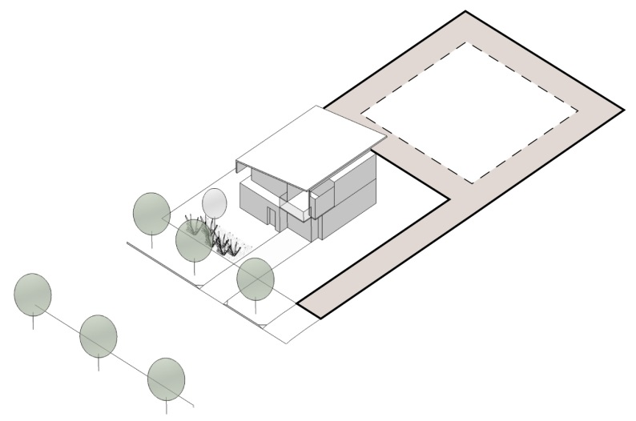
Figure 9.4.8-1
Illustration showing the Reconfiguring a lot outcomes for creation of rear lots in residential zones
Road access
Po3  Lot configuration provides safe and efficient access for vehicles and pedestrians. | AO3  All lots have legal road access in accordance with SC6.11 City Plan policy – Land development guidelines, Section 2 – Transport network standards. | complies with ao3.
Po4  The widths of access strips and easements provide safe and efficient access for vehicles and pedestrians. | AO4  Minimum widths for access strips and easements comply with Table 9.4.8-2: Minimum width of access strips or easements. | N/A
Infrastructure
PO5  New lots are created with provision of essential services and public utilities, including sewerage, water, electricity and communication services that are designed and located to:  (a) meet the needs of users;  (b) enhance the health, safety and convenience of the community;  (c) be cost effective over their life-cycle;  (d) minimise adverse impacts to the environment (including the amenity of the local area);  (e) minimise risk of failure or damage during a natural hazard event; and  (f) support connection to fibre telecommunication infrastructure. | AO5.1  All lots are connected to electricity supply and telecommunications services, with the telecommunications infrastructure designed to support connection to fibre telecommunications infrastructure. | complies with ao5.1.
 | AO5.2  Electricity supply and telecommunications infrastructure are provided underground, where the development involves the creation of more than five lots, five dwellings, or five tenancies, except in the Rural zone. | complies with ao5.2.
 | AO5.3  All new lots within the Local government infrastructure plan boundary are connected to reticulated water supply in accordance with SC6.11 City Plan policy – Land development guidelines, Section 6 – Water supply and sewerage reticulation standards, except in the Extractive industry, Rural and Conservation zones. | complies with ao5.3
 | AO5.4  All new lots within the Local government infrastructure plan boundary are connected to reticulated sewerage in accordance with SC6.11 City Plan policy – Land development guidelines, Section 6 – Water supply and sewerage reticulation standards, except in the Extractive industry, Rural and Conservation zones, and those lands within the Rural residential zone unless specifically stated in the Rural residential zone code. | complies with ao5.4
 | AO5.5  On-site water supply is provided in accordance with SC6.11 City Plan policy – Land development guidelines, Section 6 – Water supply and sewerage reticulation standards for all new lots created in the Extractive industry, Rural, Rural residential and Conservation zones or in areas outside the Local government infrastructure plan boundary. | complies with ao5.5
 | AO5.6  On-site sewage disposal is provided in accordance with Council's Guidelines for the Installation and Operation of Aerobic Wastewater Treatment Plants for Domestic and Small Scale Commercial Users 1995 and AS1547 for all new lots created in the Extractive industry, Rural, Rural residential and Conservation zones or in areas outside the Local government infrastructure plan boundary. | N/A
On-site sewerage provision
Po6  The sewerage disposal area is located in a position that is sufficiently separated from adjoining property boundaries and nearby waterways. | AO6  For development involving on-site sewage disposal, an Effluent Disposal Report prepared by a qualified expert shall be submitted demonstrating that new lots are of a sufficient size and design to allow for the required separation distances of the disposal area from:  (a) adjoining property boundaries;  (b) adjacent wastewater systems;  (c) nearby waterways;  (d) inappropriate soil types; and  (e) other general site constraints that would inhibit the disposal of wastewater to an acceptable environmental and health standard.  Note: the Effluent Disposal Report shall demonstrate the type, size and location of the effluent disposal and dispersal area, the extent of vegetation clearing that is required to achieve the disposal and dispersal area, and the extent of earthworks required to achieve the effluent disposal. | Complies with provided disposal report
Rearranging lot boundaries
po7  Rearranging a lot boundary results in lots which have practical shapes and allow for the intended uses described in the zone.  Note: irregular shaped lots will only be accepted to address encroachments. | Ao7.1  The rearranging of a lot boundary does not restrict the lawful use of either lot. | N/A
 | AO7.2  The rearranging of a lot boundary results in lots which comply with the applicable zone requirements. | N/A
 | ao7.3  The rearranging of a lot boundary ensures that a building or structure that is not intended for common use and sharing by a formal title arrangement is not located across a boundary or within a setback. | N/A
Additional provisions for volumetric subdivisions
po8  Volumetric subdivision (of the space above or below ground level) facilitates efficient delivery of development and does not result in the creation of parcels that cannot achieve any development rights, or that will not have adequate access to infrastructure.  Note: a Building Management Statement(s) (‘BMS’) may be conditioned to ensure compliance with this provision. The BMS will be required to note the continuing application of existing development permits. | ao8  No acceptable outcome provided. | N/A
po9  The volumetric subdivision does not compromise any of the requirements of the earlier development approval. | ao9  No acceptable outcome provided. | N/A
po10  Adequate access to services and facilities is provided for all lots, including water, sewer, access, car parking, etc. in accordance with earlier development approvals.  Note: a Building Management Statement(s) (‘BMS’) may be conditioned to ensure compliance with this provision. The BMS will be required to note the continuing application of existing development permits. | AO10  No acceptable outcome provided. | N/A
Housing diversity
po11  Residential subdivisions creating 10 or more lots vary lot sizes to accommodate potential multiple dwelling development where the zone allows. | AO11  No acceptable outcome provided. | N/A
po12  Small lots in residential subdivisions are distributed amongst larger lots to facilitate variation in dwelling form and to meet the purpose of the zone. | AO12  No acceptable outcome provided. | N/A
PO13  Narrow lots are distributed amongst wider lots to provide:  (a) variation in dwelling form;  (b) space for public utilities and street trees; and  (c) on-street parking.  Note: Rear lane layout is required for a series of lots with frontages less than 10m. | AO13  No acceptable outcome provided. | N/A
Creation of small lots
Po14  Reconfiguring a lot where creating small lots demonstrates a Dwelling house can be accommodated, where it meets the relevant zone code and the Small lot housing (infill focus) code, through:  (a) a site plan for all lots with an area 250m² to 400m²; and  (b) site, floor plans, and elevations for all lots with an area less than 250m².  Notes:  (a) PO14 does not apply to the creation of small lots where associated with an existing residential building.  (b) House plans provided as part of a Reconfiguring a lot application will not be conditioned as part of an approval. | AO14  No acceptable outcome provided. | n/a
Circulation and street access design
PO15  An overall street network is provided which:  (a) prioritises pedestrians and cycling over motor vehicles;  (b) establishes a connected and legible street network;  (c) provides a high level of internal accessibility and high-quality external connections for pedestrians and cyclists and appropriate external connections for vehicles;  (d) creates safe conditions for pedestrians, cyclists and vehicles for both day and night-time usage;  (e) caters for the extension of existing or future public transport routes to provide services that are convenient and accessible for all the community;  (f) facilitates connections for future development, minimising travel distances;  (g) are designed to be responsive to the natural contours of the land;  (h) facilitates safe and efficient access for service vehicles including refuse collection; and  (i) does not compromise future development to achieve the same outcomes listed above. | AO15  Streets are designed to:  (a) comply with design standards in SC6.11 City Plan policy – Land development guidelines, Section 2 – Transport network standards;  (b) establish a safe walkable and permeable street network that provides clear pedestrian and cycle access to commercial, public transport, parks and community service areas;  (c) provide street trees in accordance with SC6.12 City Plan policy – Landscape work;  (d) allow for efficient, safe and unimpeded movement of buses alongside pedestrians, cyclists and other motorists;  (e) incorporate signals, pedestrian refuge and splitter islands for the safe crossing of pedestrians and cyclists for intersections and long roads;  (f) accommodate service vehicle requirements;  (g) have footpaths that link to existing footpaths, road crossings, parks and public transport facilities, and designed in accordance with SC6.11 City Plan policy – Land development guidelines, Section 2 – Transport network standards;  (h) provide street lighting in accordance with SC6.11 City Plan policy – Land development guidelines, Section 2 – Transport network standards; and  (i) provide for future extensions to the street network. | N/A
PO16  Development within the Coomera Town Centre area provides an integrated network of predominantly public streets to ensure efficient movement of pedestrians, cyclists, vehicles and strong public transport connections.  Note: indicative access and mobility outcomes for the Coomera Town Centre area are identified on Figure 9.4.13-2 within Part 9.4.13 Transport code. | AO16  No acceptable outcome provided. | N/A
Additional provisions for subdivisions which result in the creation of 20 lots or more
Neighbourhood design, character and integration
po17  Development provides a neighbourhood with a strong and positive identity, through:  - clearly readable streets and useable open space networks;  - an appropriate response to site characteristics and settings (including landmarks and views);  - development of a scale consistent with the surrounding urban area, with open space and roads interconnecting to adjoining networks;  - allowing for increased densities in close proximity to public transport and local services;  - location of community, retail and commercial facilities at walkable focal points; and  - providing for a safer community by maximising opportunities for casual surveillance, minimising opportunities for crime and vandalism.  Note: a Comprehensive Plan of Development submitted as part of a material change of use application, prepared in accordance with SC6.6 City Plan policy – Comprehensive plans of development, is Council’s preferred method of addressing the above outcomes. | AO17  No acceptable outcome provided. | N/A
Climatically responsive design
Po18  The street and lot orientation facilitates the construction of energy-efficient buildings that respond to the local climatic conditions by:  (a) maximising solar access to the north in winter;  (b) minimising solar access to the east and west in the summer;  (c) maximising access to any prevailing summer breezes; and  (d) minimising exposure to prevailing winter winds. | AO18.1  A site analysis prepared in accordance with SC6.13 City Plan policy – Site analysis identifies how the proposed lot orientation results in the potential for energy efficient buildings that respond to the local climatic conditions. | complies with ao18.1
 | AO18.2  Roads and lots are generally configured in a grid pattern and run in:  (a) north-south direction within 20º west and 30º east of north; and  (b) east-west direction within 30º south and 20º north of east. | complies with ao18.2
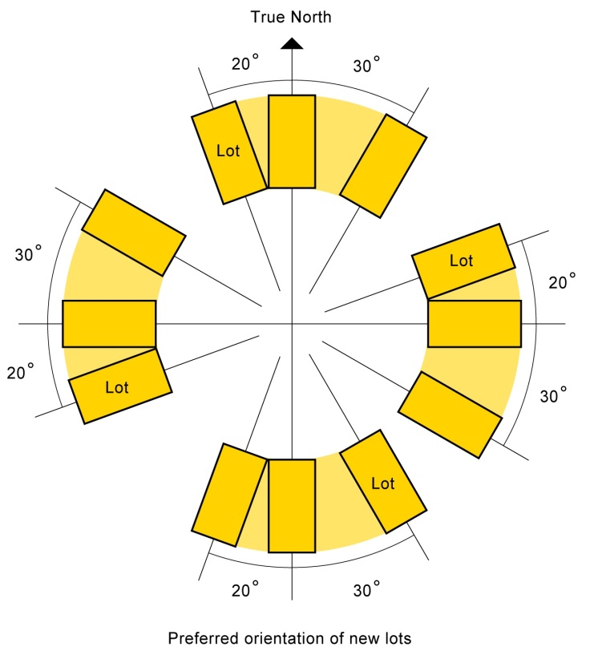
Figure 9.4.8-2
Illustration showing the Reconfiguring a lot preferred lot orientation outcomes
Public transport integration
Po19  Subdivision design supports public transport integration. | AO19  At least 60% of lots are within 400m walking distance of roads which have a minimum carriageway width of 10m and are capable of supporting a bus route. | N/A
Retail and community services
Po20  Large developments include a site for the location of neighbourhood stores and community facilities to promote a walkable neighbourhood.  Note: an adaptable sales office which is used as a shop after the completion of subdivision sales would satisfy this performance outcome. | AO20.1  Lots are allocated and designed to accommodate neighbourhood stores and for community facilities in subdivisions of more than 250 lots. | N/A
 | AO20.2  Any lots identified as suitable for neighbourhood stores or community facilities are located in prominent and easily accessible locations within the development. | N/A
Open space provision
Po21  A public open space network is provided which:  (a) has a range of recreation settings and adequate facilities to meet the needs of the community;  (b) offers opportunities for residents to conveniently participate in passive recreational activities;  (c) delivers well distributed public open space that contributes to the legibility, accessibility, safety, and character of the development;  (d) creates safe and attractive settings and focal points;  (e) facilitates casual surveillance from adjacent streets and land uses and provides for open space areas with public road frontages;  (f) delivers stormwater and flood management and care of valuable environmental resources; and  (g) is cost effective to maintain. | AO21.1  Land intended for public open space is of a physical standard and condition in accordance with the SC6.11 City Plan policy – Land development guidelines, Section 5 – Public open space standards. | N/A
 | AO21.2  For trunk recreational open space  Recreation and sporting parklands and land for community facilities are designed and provided in accordance with the Local government infrastructure plan and approved Council master plans.  OR  Public open space is provided in accordance with an already approved open space strategy, relevant approved material change of use, adopted concept plan, master plan or structure plan. | N/A
 | AO21.3  For non-trunk recreational open space  Residential subdivisions creating more than 100 lots provide a minimum of 20m² of land per dwelling, for open space that is:  (a) within 400m walking distance of all residential lots; and  (b) designed to adequately meet the recreational needs of users. | N/A
po22  The design and location of open space results in high-quality parkland which:  (a) enables the retention and protection of matters of environmental significance, their associated buffers, assessable vegetation, habitat features and natural cultural features;  (b) contributes to the visual amenity of the area and facilitates casual surveillance;  (c) can be easily accessed along road frontages;  (d) directly adjoins existing or proposed open space areas; and  (e) creates opportunities for linkages between open space areas. | AO22.1  Open space is provided adjacent to waterway buffers with roads servicing linear parkland, and lots located on the opposite side of the road. | N/A
 | AO22.2  Open space for conservation purposes is consolidated with other conservation areas to allow for a connected movement corridor. | N/A
 | AO22.3  Recreational open space areas less than 5,000m² directly adjoin existing or proposed recreational open space areas to provide:  (a) a consolidated useable area; and  (b) connectivity between open spaces. | N/A
Open space, safety and design
PO23  Open space areas are designed and managed to promote user safety. | AO23.1  Areas intended for use during times of darkness are lit in accordance with SC6.11 City Plan policy – Land development guidelines, Section 5 – Public open space standards. | N/A
 | AO23.2  Casual surveillance is achieved by parks and open space being overlooked by housing, commercial or other development, as well as passing pedestrian and vehicle traffic. | N/A
 | AO23.3  Fencing greater than 1.2m in height adjoining a park is to be at least 50% transparent (i.e. swimming pool style or timber picket fencing) and any landscaping adjacent to the fence is to be designed to maximise the opportunity for casual surveillance. | N/A
Staging of subdivision
Po24  Staging of the subdivision ensures that safe and convenient access to public transport, open space, community facilities, convenience shopping and local employment opportunities integrate with community need. | AO24  No acceptable outcome provided. | N/A

Table 9.4.8-2: Minimum width of access strips or easements
Zone | Minimum width of access strips or easements (metres)
Rural | 10
Rural residential | 6
Township | 4.5
Low density residential | 4.5
Medium density residential | 4.5
High density residential | 6.0
Centre | 4.5
Neighbourhood centre | 4.5
Mixed use | 8
Medium impact industry | 8
Low impact industry | 8
Extractive industry | 10
Waterfront and marine industry | 8
Community facilities | 4.5
Sport and recreation | 4.5
Open space | 15
Emerging community | No acceptable outcome provided
Conservation | No acceptable outcome provided
Limited development (constrained land) | No acceptable outcome provided
Special purpose | No acceptable outcome provided
Innovation | 4.5
Major tourism | No acceptable outcome provided

City Plan code template
This code template supports the preparation of a development application against either the acceptable outcome(s) or performance outcome(s) contained in the code. Development assessment rules are outlined in Section 5.3.3 of the City Plan.
Please note:
For assessment against the overall outcomes, refer to the appropriate code.
Note: The whole of the planning scheme is identified as the assessment benchmark for impact assessable development. This specifically includes assessment of impact assessable development against this strategic framework. The strategic framework may contain intentions and requirements that are additional to and not necessarily repeated in zone, overlay or other codes. In particular, the performance outcomes in zone codes address only a limited number of aspects, predominantly related to built form. Development that is impact assessable must also be assessed against the overall outcomes of the code as well as the strategic framework.
    - General development provisions code
      - Application
The code applies to assessing material change of use, building work, reconfiguring a lot or operational work where indicated within Part 5 Tables of assessment.
When using this code, reference should be made to Section 5.3.2 and, where applicable, Section 5.3.3, in Part 5.

9.4.4.2 Purpose
(1) The purpose of the General development provisions code is to provide a consistent approach to city wide issues and avoid duplication of regulation throughout the City Plan.
(2) The purpose of the code will be achieved through the following overall outcomes:
(a) Development is designed to maintain the expected level of amenity for the area.
(b) Development promotes a safe environment and reduces the potential for crime.
(c) Development is designed to respect the natural values of the land, including vegetation, natural topography and development on steep slopes to minimise impacts on the landscape character of the city's rural, urban and hinterland areas.
(d) Development does not result in unsightly retaining walls.
(e) Building services and storage areas are designed and located to avoid nuisance to adjoining premises and avoid an unattractive appearance when viewed from the street.
(f) Development does not cause adverse stormwater drainage impacts on or off the site.
(g) Development is connected to essential services and public utilities in accordance with infrastructure provider requirements.
(h) Development is designed and located to ensure it does not adversely impact on Council infrastructure.

9.4.4.3 Specific benchmarks for assessment
Table 9.4.4-2: General development provisions code – for assessable development
Performance outcomes | Acceptable outcomes | Does the proposal meet the acceptable outcome?  If not, justify how the proposal meets either the performance outcome or overall outcome | Internal use
Amenity protection
po1  Development mitigates any negative effects to amenity, health and safety from existing surrounding activities having regard to:  - noise;  - hours of operation;  - traffic;  - signage;  - visual amenity;  - wind effects;  - privacy;  - vibration;  - contaminated substances;  - hazardous chemicals;  - odour and emissions; and  - safety. | AO1  No acceptable outcome provided. | complies with po1
po2  The proposed development prevents loss of amenity and threats to health and safety, having regard to:  - noise;  - hours of operation;  - traffic;  - signage;  - visual amenity;  - wind effects;  - privacy;  - vibration;  - contaminating substances;  - hazardous chemicals;  - odour and emissions; and  - safety. | AO2  No acceptable outcome provided. | complies with po2
Development along the Pacific Motorway and heavy railway line
po3  Development adjacent to the Pacific Motorway and heavy railway line minimises views of the storage of outdoor plant and equipment, including service areas to provide an attractive outlook for persons using the transport network. | AO3  Where the site is adjacent to the Pacific Motorway or a heavy rail line, areas used for outdoor storage, including service areas are screened from view from users of the motorway or heavy rail line by buildings, solid fencing or vegetation. | N/A
Landscaping
po4  The proposal provides landscape work that protects and enhances the character of the local area. | AO4.1  For all development except dwelling houses, dual occupancies, caretaker’s accommodation and community residences a Statement of Landscape Intent prepared in accordance with SC6.12 City Plan policy – Landscape work demonstrating that the landscaping will provide amenity for site users and will protect and enhance the character of the local area.  AO4.2  An Open Space Management Statement is prepared in accordance with SC6.12 City Plan policy – Landscape work where landscape works are proposed to be undertaken on land that is or is intended to be, public open space. | N/A
Building services
po5  All mechanical equipment is located and housed so as not to cause disturbance to residents within or adjoining the development. | AO5  For all development except dwelling houses, dual occupancies, caretaker’s accommodation and community residences:  The mechanical equipment, including air-conditioning plant and swimming pool pumps, is incorporated within the building.  OR  The mechanical equipment, including air-conditioning plant and swimming pool pumps, is housed external to the principal building and:  - is contained within a solid structure; and  - located no closer than 1.5m to any site boundary. | N/A
Casual surveillance and lighting
Po6  Development facilitates casual surveillance of public areas and incorporates lighting to reduce opportunities for crime. | AO6  No acceptable outcome provided. | N/A
Lighting
Po7  Lighting associated with any development does not cause a nuisance. | AO7  Direct or reflected light emissions from the premises must be positioned and shielded to prevent light spillage outside the boundaries of the site. | N/A
Shadow impacts – for all development 3 or more storeys
po8  The building is designed and located to ensure that the shadow cast by the building does not detract from a comfortable living and ground level environment and the access of adequate sunlight to private and public spaces having regard to:  - the degree of containment of the shadow on the subject site at different times of the day on the summer and winter solstice and spring and autumn equinox;  - the cumulative impact of the shadow and existing shadows;  - the effect of the shadow on the ocean beach, Broadwater foreshore, or riverside or beachside public open space;  - the location of the shadow on non-residential areas external to the site; and  - the effect of the shadow on any other site or other building. | AO8.1  The width of the shadow cast in any direction by each level of the building, excluding balconies and lift wells, does not exceed twice the width of the shadow cast in any other direction.  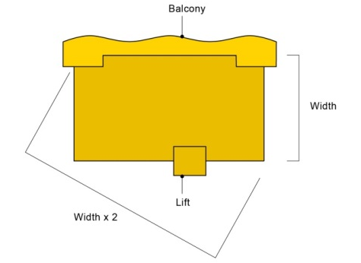  Figure 9.4.4-1  Illustration showing width ratio shadow outcome | N/A
 | AO8.2  The shadow cast by the building in a true south direction has a length 0.25 times the height of the building, as measured from ground level adjacent to the southern side of the subject building to the top of the topmost storey, and does not intrude onto any other site, or does not cast shadow onto any other building on the same site.  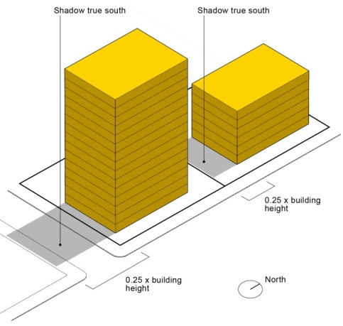  Figure 9.4.4-2  Illustration showing southern shadow outcome | N/A
 | AO8.3  Bermuda Point precinct  The shadow cast by the building in a true south direction has a length 0.25 times the height of the building, as measured from the top of the podium adjacent to the southern side of the subject building to the top of the topmost storey, and does not intrude onto any other site, or does not cast shadow onto any other building on the same site.  Note: The podium is excluded from any southern shadow calculations. | N/A
 | AO8.4  The shadow cast by any building does not cover any part of the ocean beach or Broadwater foreshore when the shadow has a bearing of 145° east of true north and the length of the shadow is 1.6 times the height of the building as measured from the ground level to the top of the topmost storey.  Note: For the purpose of this acceptable outcome, the ocean beach is defined as that area east of a line 10m east of and parallel to the foreshore seawall line and the Broadwater foreshore is defined as that area east of the leading edge of the revetment wall.  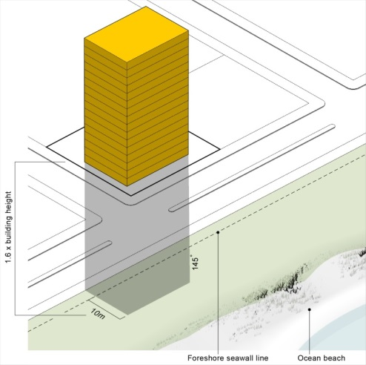  Figure 9.4.4-3  Illustration showing ocean beach and Broadwater foreshore shadow outcome | N/A
 | AO8.5  The shadow cast by the building in the direction of true south does not intrude more than 10m into a riverside public open space reserve. | N/A
Earthworks and treatment of retaining walls
po9  Earthworks and retaining walls associated with the development do not create a negative visual impact upon neighbouring properties or the streetscape. | AO9  Retaining walls and batters comply with the requirements of SC6.11 City Plan policy – Land development guidelines, Section 3 – Change to ground level standards. | will comply with ao9
Stormwater drainage
PO10  Development does not cause adverse stormwater drainage impacts on or off the site. | AO10  All development incorporates stormwater drainage works to comply with the requirements of SC6.11 City Plan policy – Land development guidelines, Section 4 – Stormwater drainage and water sensitive urban design standards. | will comply with ao10
Infrastructure
PO11  All development ensures connection to public utilities to meet the needs of the development, including sewer, water, electricity and communications services. | AO11  All development is provided with services, as follows:  - electricity supply and communication services  - reticulated water supply, when within the mapped ‘water supply service area’ identified in the Local government infrastructure plan, and not located in the Conservation, Extractive industry, Major tourism (Island resorts precinct), Open space or Rural zones  - reticulated sewer network, when within the mapped ‘wastewater service area’ identified in the Local government infrastructure plan, and not located in the Conservation, Extractive industry, Major tourism (Island resorts precinct), Open space, Rural or Rural residential zones. | will comply with ao11
PO12  Development is undertaken in accordance with the Performance Criteria specified in the Queensland Development Code MP1.4 – Building over or near relevant infrastructure. | AO12  Development is undertaken in accordance with the Acceptable Solutions specified in the Queensland Development Code MP1.4 – Building over or near relevant infrastructure. | will comply with ao12
Site analysis
PO13  Development is designed to:  - complement the character and address any impacts on the amenity and environment of the local area;  - avoid any risk to life or property arising from natural hazards; and  - protect significant natural habitat areas, wildlife corridors, wetlands and waterway corridors. | AO13  A site analysis plan is prepared in accordance with SC6.13 City Plan policy – Site analysis. | complies with ao13.

City Plan code template
This code template supports the preparation of a development application against either the acceptable outcome(s) or performance outcome(s) contained in the code. Development assessment rules are outlined in Section 5.3.3 of the City Plan.
Please note:
For assessment against the overall outcomes, refer to the appropriate code.
Note: The whole of the planning scheme is identified as the assessment benchmark for impact assessable development. This specifically includes assessment of impact assessable development against this strategic framework. The strategic framework may contain intentions and requirements that are additional to and not necessarily repeated in zone, overlay or other codes. In particular, the performance outcomes in zone codes address only a limited number of aspects, predominantly related to built form. Development that is impact assessable must also be assessed against the overall outcomes of the code as well as the strategic framework.
    - Healthy waters code
      - Application
This code applies to assessing material change of use or reconfiguring a lot for development where indicated within Part 5 Tables of assessment unless either of the following circumstances apply:
(1) No increase in impervious area is required onsite for the development.
(2) A stormwater quality and quantity management plan previously approved by the Council has been fully implemented within the existing development layout.
Note: Where a development proposal meets either (1) and (2) above, this code is not applicable.
When using this code, reference should be made to Section 5.3.2 and, where applicable, Section 5.3.3, in Part 5.

9.4.5.2 Purpose
(1) The purpose of the Healthy waters code is to protect the quality of the city’s waters from the impacts of development.
(2) The purpose of the code will be achieved through the following overall outcomes:
(a) Urban stormwater quality management, wastewater management, and management of waters are based on the following principles:
(i) Development and construction activities are conducted to achieve the water quality objectives, as specified in the Environmental Protection (Water) Policy 2009.
(ii) The ongoing management of urban stormwater quality reflect the regional climate and the site’s landscape characteristics.
(iii) Development is undertaken in accordance with best practice environmental management.
(iv) Development avoids adverse impacts on the City of Gold Coast’s waters or, where this is not feasible, adverse impacts are minimised.
(b) Water resource catchments are protected from contamination by chemicals.
(c) The drainage capacity of the Woongoolba Flood Mitigation Scheme Area for rainfall events up to 1 in 10 year 72 hours is maintained (contained within the Scheme drains within a 4 day period) and this capacity is not be eroded due to cumulative impact of development.

9.4.5.3 Specific benchmarks for assessment
Table 9.4.5-2: Healthy waters code – for assessable development
Performance outcomes | Acceptable outcomes | Does the proposal meet the acceptable outcome?  If not, justify how the proposal meets either the performance outcome or overall outcome | Internal use
Stormwater quality
po1  Development appropriately manages stormwater quality to:  - protect natural ecosystems;  - integrate stormwater treatment into the urban landscape;  - protect water quality;  - reduce runoff and peak flows; and  - meet the water quality objectives and environmental values for Queensland waters.  Note: Water quality objectives and environmental values for Queensland waters are contained within Schedule 1 of the Environmental Protection (Water) Policy 2009. Water quality objectives are locally specific and vary between and within river catchments. | AO1.1  Where development is:  - for a dwelling house, dual occupancy or multiple dwelling on a lot less than 5000m²; or  - light industry or business activity on a lot less than 2500m²,  it complies with the ‘Deemed to comply’ requirements detailed in the Stormwater quality management guidelines in SC6.11 City Plan policy – Land development guidelines, Section 4 – Stormwater drainage and water sensitive urban design standards. | N/A
 | AO1.2  Where development is:  - for a dwelling house, dual occupancy or multiple dwelling on a lot equal to or more than 5000m² but less than 1.25 ha; or  - light industry or business activity on a lot equal to or more than 2500m² but less than 1.25 ha;  - it complies with the ‘Deemed to comply’ requirements detailed in the Stormwater quality management guidelines in SC6.11 City Plan policy – Land development guidelines, Section 4 – Stormwater drainage and water sensitive urban design standards. | N/A
 | AO1.3  Where development is not listed in AO1 a Stormwater Quality Management Plan is prepared by a suitably-qualified person in accordance with the Stormwater quality management guidelines in SC6.11 City Plan policy – Land development guidelines, Section 8 – Engineering drawings, documents and reports. | N/A
Stormwater quantity
po2  Stormwater quantity management outcomes demonstrate no adverse impact on stormwater flooding or the drainage of properties external to the subject site. | AO2  A stormwater quantity management plan is prepared by a suitably qualified person and demonstrates:  - achievable stormwater quantity control measures for discharge during both the construction and operational phases of development designed in accordance with the Queensland Urban Drainage Manual (QUDM) unless subject to specific requirements of SC6.11 City Plan policy – Land development guidelines, Section 4 – Stormwater drainage and water sensitive urban design standards;  - on-site detention systems that are designed to restrict peak outflows for Q2, Q5, Q10, Q20 Q50 and Q100 to pre-development conditions. | Complies
Woongoolba Flood Mitigation Scheme Catchment Area
PO3  In the Woongoolba Flood Mitigation Scheme Catchment Area, shown on the Water catchments and dual reticulation overlay map, peak outflow and its timing for Q2, Q5 and Q10 for rainfall events up to 72 hours does not change as a result of development. | AO3  No acceptable outcome provided. | n/a
Protection of natural flows (discharge)
PO4  Construction and operational activities avoid or minimise adverse impacts of altered stormwater quality and quantity. | AO4  Development achieves the Frequent Flow Management and Waterway Stability Management design objectives as stated within Chapter 2 – Section 2.4.2 of the Urban Stormwater Quality Planning Guidelines 2010.  Note: A site Stormwater Quality and Quantity Management Report prepared by a suitably qualified person is Council’s preferred method required to be submitted to Council to address this Acceptable outcome.  The intent in the above guidelines (Urban Stormwater Quality Planning Guidelines 2010) can be achieved by adopting Water Sensitive Urban Design (WSUD) concepts within the development. | n/a
Wastewater management
PO5  Development does not discharge wastewater to receiving waters or areas external to the site unless demonstrated to be the best-practice environmental management for that site and takes into consideration:  - the applicable water quality objectives for the receiving waters; and  - the potential adverse impact on ecosystem health of receiving waters. | AO5  Where the development involves the discharge of wastewater, a Wastewater Management Plan (WWMP) is prepared, demonstrating compliance with the performance outcome, by a suitably qualified person and submitted to the Council, detailing all of the following:  - wastewater type;  - climatic conditions;  - water quality objectives;  - best-practice environmental management;  - waste management hierarchy; and  - the WWMP provides for the management of wastewater in accordance with a wastewater management hierarchy that:  - avoids wastewater discharge to waterways; or  - if wastewater discharge to the environment cannot practicably be avoided wastewater discharge to waterways is minimised through re-use, recycling, recovery and treatment for disposal to sewer, surface water and groundwater. | n/a
Erosion and sediment control (ESC)
PO6  Development does not cause erosion or allow sediments to leave the site. | AO6  An Erosion hazard assessment completed in accordance with the criteria in Table 9.4.5-3 is undertaken to establish the level of risk for soil erosion and sediment pollution to the environment.  Where the Erosion hazard assessment has a risk score less than or equal to 10:  A deemed to comply report is prepared by a suitably qualified person for Council approval, including conceptual location and design drawings of each treatment measure in plan and section views, in accordance with the Best Practice Erosion and Sediment Control: International Erosion Control Association, (IECA) 2008, Australasia Chapter 2008.  Where the Erosion hazard assessment has a risk score greater than 10:  A conceptual erosion and sediment control plan (ESCP) is prepared by a suitably qualified person for Council approval in accordance with the Best Practice Erosion and Sediment Control: International Erosion Control Association, (IECA) 2008, Australasia Chapter 2008. | will comply with ao6.

City Plan code template
This code template supports the preparation of a development application against either the acceptable outcome(s) or performance outcome(s) contained in the code. Development assessment rules are outlined in Section 5.3.3 of the City Plan.
Please note:
For assessment against the overall outcomes, refer to the appropriate code.
Note: The whole of the planning scheme is identified as the assessment benchmark for impact assessable development. This specifically includes assessment of impact assessable development against this strategic framework. The strategic framework may contain intentions and requirements that are additional to and not necessarily repeated in zone, overlay or other codes. In particular, the performance outcomes in zone codes address only a limited number of aspects, predominantly related to built form. Development that is impact assessable must also be assessed against the overall outcomes of the code as well as the strategic framework.
    - Rural residential zone code
      - Application
This code applies to assessing all development in the Rural residential zone.
When using this code, reference should be made to Section 5.3.2 and, where applicable, Section 5.3.3, in Part 5.
Where development is identified in the Rural residential landscape and environment precinct, additional outcomes will apply.
Note: To the extent there is any inconsistency with the outcomes applying to the whole of the zone, the precinct outcomes will prevail.

6.2.21.2 Purpose
(1) The purpose of the Rural residential zone code is to provide for residential development on large lots where local government infrastructure and services may not be provided on the basis that the intensity of residential development is generally dispersed.
(2) The purpose of the code will be achieved through the following overall outcomes:
(a) Land uses –
(i) support the rural lifestyle and amenity aspirations of residents residing in the semi-rural or bushland environment;
(ii) provide low rise, very low intensity residential accommodation such as Dwelling houses, and Short-term accommodation (farm stays) but not Party houses;
(iii) preserve the matters of environmental significance and topographical features of the land by integrating uses of appropriate scale amongst the landscape;
(iv) non-residential uses such as Child care centres, Shops and Clubs may be appropriate where they meet the day-to-day needs of the residential catchments and do not compromise the amenity and character of the zone and local area;
(v) that have potential for higher impacts on amenity but contribute to the semi-rural use of the zone may be considered where they are appropriately designed and located, such as Animal keeping, Animal husbandry and Intensive horticulture;
(vi) that do not directly relate to the semi-rural operation of the zone may be considered such as Garden centres, Veterinary services, Community care centres, Community uses, Education establishments, Places of worship, Environmental facilities and Tourist attractions, Emergency services and Transport depot where they do not compromise the amenity and character of the zone; and
(vii) do not detract from the residential amenity of the area.
(b) Character consists of –
(i) very low intensity and low rise environments; and
(ii) private acreage or bushland living, typically situated along natural landscape settings like ridgelines or valleys with the intention of being separated from urban services and providing a high amenity lifestyle choice.
(c) Built form –
(i) is very low intensity, low rise and well setback from property boundaries to ensure privacy for adjacent residences and to preserve the very low intensity character of the zone;
(ii) maintains a low site cover to promote the semi-rural or bushland setting; and
(iii) respects natural landscape values of semi-rural and bushland environments.
(d) Lot design –
(i) results in lot sizes and dimensions appropriate for the large lot residential locality that recognise the site’s inherent values, constraints and character and supports very low density;
(i) provides an average lot size of no less than 8,000m² to protect local amenity and character. To respond to the various constraints found in the zone the lot sizes may vary provided that no lot has an area less than 4,000m²; and
(ii) additional outcomes where identified on the Minimum lot size overlay map:
• facilitates the subdivision pattern and desired character of the locality by meeting the minimum lot size identified on the Minimum lot size overlay map; and
• provides connection to reticulated sewerage in accordance with SC6.11 City Plan Policy – Land development guidelines, where the lot size on the Minimum lot size overlay map is equal to or less than 2,500m².
(e) Variations in the zone are –
(i) Rural residential landscape and environment precinct.
(3) The purpose of the Rural residential landscape and environment precinct will be achieved through the following additional overall outcomes:
(a) Subdivision avoids fragmentation of identified matters of environmental significance and natural landscape values.
(b) Low key nature based activities such as cafés, camping grounds, and eco-tourism may be supported where they support the identified landscape and environment values.
(c) Inappropriate activities that may erode the matters of environmental significance, recreational, landscape and scenic amenity values of natural landscape and environment areas are not supported.
(d) Development supports the protection and regeneration of identified matters of environmental significance.

6.2.21.3 Specific benchmarks for assessment
Table 6.2.21-2: Rural residential zone code – for assessable development
Performance outcomes |  | Acceptable outcomes |  | Does the proposal meet the acceptable outcome?  If not, justify how the proposal meets either the performance outcome or overall outcome | Internal use
Setbacks
po1  Setbacks:  (a) provide privacy to adjacent dwellings;  (b) allow for access around the building;  (c) contribute to the semi-rural streetscape character; and  (d) allow for on-site car parking. |  | AO1  Setbacks are as follows: |  | N/A
 |  | Setback | Minimum distances measured in metres (m) | N/A
 |  | Front | • if roadside stall: 0m  • otherwise: 6m | N/A
 |  | Side and rear | 3m | N/A
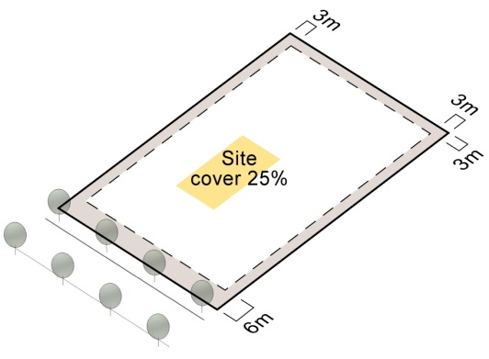

Figure 6.2.21-1
Illustration showing Rural residential zone setbacks and site cover outcomes
Site cover
po2  Site cover:  (a) is low to protect the rural residential character; and  (b) provides areas for on-site sewerage facilities. |  | AO2  Site cover does not exceed 25%. |  | N/A
Po3  Rural residential landscape and environment precinct  Site cover is very low to protect the identified matters of environmental significance and natural landscape values. |  | AO3  Rural residential landscape and environment precinct  Development is confined only to previously cleared areas and site cover does not exceed 15%. |  | n/a
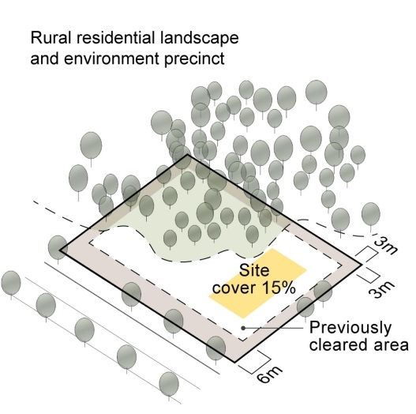
Figure 6.2.21-2
Illustration showing Rural residential landscape and environment precinct site cover outcomes
Height
po4  Building height is low rise. |  | AO4.1  Building height does not exceed:  (a) 2 storeys with a maximum height of 9m; or  (b) a partial third storey if within 9m.  AO4.2  Structures do not exceed a height of 9m. |  | n/a
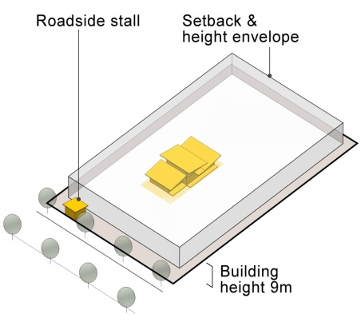
Figure 6.2.21-3
Illustration showing Rural residential zone height outcomes
Density
PO5  Residential density is limited to a dwelling house. |  | AO5  No acceptable outcome provided. |  | n/a
Design and appearance
Po6  Buildings are integrated within the landscape and do not appear as a prominent feature. |  | AO6  Buildings and structures do not protrude above ridgelines when viewed from any street. |  | n/a
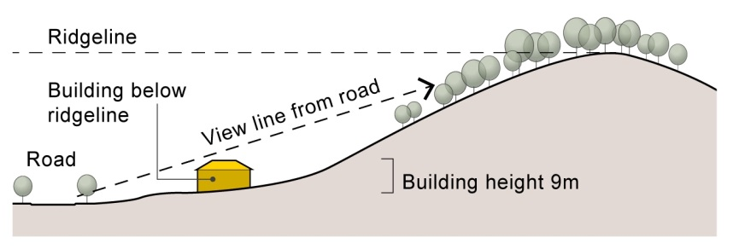
Figure 6.2.21-4
Illustration showing Rural residential zone amenity where buildings are integrated within the landscape and do not appear as a prominent feature
Lot design (for subdivision only)
PO7  Where not on the Minimum lot size overlay map or Rural residential landscape and environment precinct  Average lot size is no less than 8,000m² and no lots have an area less than 4,000m².  Note: this provision does not apply to land that is to be dedicated to Council or State for open space or infrastructure purposes. |  | AO7  No acceptable outcome provided. |  | COMPLIES
PO8  Where not on the Minimum lot size overlay map or Rural residential landscape and environment precinct  Lot configuration creates a very low intensity semi-rural or bushland residential environment. |  | AO8  Minimum road frontage is 50m.  OR  For rear lots the average lot width is 50m. |  | COMPLIEs
PO9  Minimum lot size overlay map  Lot size is not less than that shown on the Minimum lot size overlay map. |  | AO9  Minimum lot size overlay map  No acceptable outcome provided. |  | N/A
PO10  Minimum lot size overlay map  Lot configuration is as follows: |  | AO10  Minimum lot size overlay map  No acceptable outcome provided. |  | N/A
Minimum lot size | Minimum frontage width
2000m² | 15m
2500m² | 15m
3500m² | 15m
4000m² | 50m
PO11  Minimum lot size overlay map  Average lot width for a rear lot is as follows: |  | AO11  Minimum lot size overlay map  No acceptable outcome provided.
Minimum lot size designation | Average lot width
2000m² - 3500m² | 15m
4000m² | 50m
PO12  Minimum lot size overlay map  Any proposed lots with a designated minimum lot size of 2,500m² or less on the Minimum lot size overlay map are connected to reticulated sewerage in accordance with SC6.11 City Plan policy – Land development guidelines. |  | AO12  Minimum lot size overlay map  No acceptable outcome provided. |  | N/A
Po13  Rural residential landscape and environment precinct  Lots are of a size that:  (a) promote the intent of the precinct; and  (b) prevent fragmentation of identified matters of environmental significance and natural landscape values.  Note: this provision does not apply to land that is to be dedicated to Council or State for open space or infrastructure purposes. |  | AO13.1  Rural residential landscape and environment precinct  Minimum lot size is 16,000m². |  | n/a
 |  | AO13.2  Rural residential landscape and environment precinct  Minimum road frontage is 50m. |  | n/a
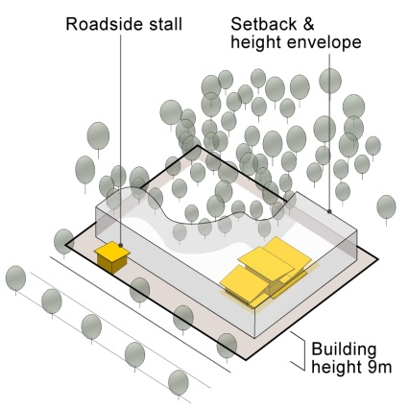
Figure 6.2.21-5
Illustration showing Rural residential landscape and environment precinct where identified natural landscape values are not impacted on as a result of land fragmentation

City Plan code template
This code template supports the preparation of a development application against either the acceptable outcome(s) or performance outcome(s) contained in the code. Development assessment rules are outlined in Section 5.3.3 of the City Plan.
Please note:
For assessment against the overall outcomes, refer to the appropriate code.
Note: The whole of the planning scheme is identified as the assessment benchmark for impact assessable development. This specifically includes assessment of impact assessable development against this strategic framework. The strategic framework may contain intentions and requirements that are additional to and not necessarily repeated in zone, overlay or other codes. In particular, the performance outcomes in zone codes address only a limited number of aspects, predominantly related to built form. Development that is impact assessable must also be assessed against the overall outcomes of the code as well as the strategic framework.

8.2.3 Bushfire hazard overlay code

8.2.3.1 Application
This code applies to assessing material change of use and reconfiguring a lot for development subject to the Bushfire hazard overlay and identified in Part 5.10 Categories of development and assessment – Overlays.
When using this code, reference should be made to Section 5.3.2 and, where applicable, Section 5.3.3, in Part 5.

8.2.3.2 Purpose
(1) The Bushfire hazard overlay constrains areas of land identified as very high, high or medium bushfire hazard and potential impact buffers. It applies, at a minimum, to development that:
(a) increases the number of people living and working in the bushfire hazard area, except where the premises are occupied on a short term or intermittent basis; or
(b) involves uses where evacuating people may be difficult; or
(c) involves the manufacture or storage of hazardous materials in bulk.
Note: Land shown on the bushfire hazard overlay map is designated as the bushfire hazard area (bushfire prone area) for the purposes of section 12 of the Building Regulation 2006. The Building Act 1975 adopts the requirements of the Building Code of Australia and AS3959 and thus regulates construction standards of all premises identified in bushfire prone areas subsequent to development approval.
(2) The purpose of the Bushfire hazard overlay is to ensure that risk to life, property and the environment as a result of bushfire is mitigated to an acceptable or tolerable level.
(3) The purpose of the code will be achieved through the following overall outcomes:
(a) Land use and development is located, designed and managed to mitigate the risk to life and property, but does not occur at the expense of other identified environmental values
(b) Development is designed to have adequate bushfire radiation zones and road layouts which do not restrict the operational requirements of fire fighters and provides safe entry and exit for residents during bushfire events.
(c) Development is provided with water-supply facilities, fire-fighting vehicle fittings and appropriate access arrangements for fire fighters and ongoing fire management.
(d) Development supports the ecological role of fire in the landscape and ensures that hazard reduction and conservation burns can be conducted in the city’s natural areas.
(e) Development in bushfire hazard areas is avoided where conservation and landscape protection constraints preclude necessary risk-reduction measures, including clearing and provision of adequate access. Bushfire hazard and risk mitigation treatments associated with new development does not have a significant negative impact on the biodiversity and health of the city’s ecosystems.

8.2.3.3 Specific benchmarks for assessment
Table 8.2.3-2: Bushfire hazard overlay code – for assessable development
Performance outcomes | Acceptable outcomes | Does the proposal meet the acceptable outcome?  If not, justify how the proposal meets either the performance outcome or overall outcome | Internal use
Bushfire hazard
po1  In a bushfire hazard area, the fire mitigation methods used at the site are adequate for the bushfire hazard of the individual site, having regard to:  (a) vegetation type;  (b) slope;  (c) aspect;  (d) bushfire history;  (e) conservation values of the site;  (f) ecological restoration, including forest succession;  (g) ongoing maintenance;  (h) climate change; and  (i) on site and off-site¹ fire hazard implications.  ¹Note: This includes potential hazard from land up to 10kms away from the site. For example, how might large tracts of forest away from the site impact on the bushland that surrounds the site. | AO1  A written assessment by a suitably qualified and experienced bushfire management consultant confirms that the site is not in a bushfire hazard area.  OR  The development complies with an approved Bushfire management plan prepared in accordance with SC6.3 City Plan policy – Bushfire management plans.  OR  The development complies with an existing approved Bushfire management plan as referenced within the approved reconfiguration of a lot.  Note: Prior to:  (a) plan sealing for a Reconfiguration of a lot; or  (b) the issue of a Building final or Certificate of classification for Building work; or  (c) the commencement of use where building work is not proposed.  Whichever comes first, the applicant must submit to Council, certification from an appropriately qualified and experienced person that the development has been completed in accordance with, and complies with the approved Bushfire management plan and that all risk treatments are functioning in accordance with the approved plan. | COMPLIES- Please refer to bushfire management plan.
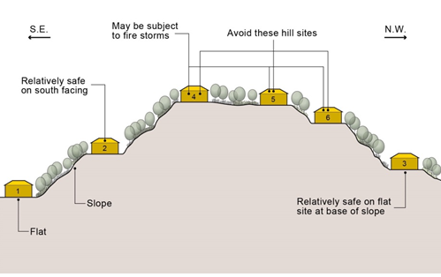
House sites are numbered in order of degree of fire safety

Figure 8.2.3-1
Bushfire hazard overlay – Preferred house site location in bushfire hazard areas. Image adapted from QDHLGP (1993) Bushfire Hazard Planning in Queensland.
Land use
po2  In a bushfire hazard area, development:  (a) does not result in a high concentration of people living, working or congregating in a bushfire hazard area;  (b) does not result in the bulk manufacture or storage of hazardous materials; and  (c) ‘essential’ community infrastructure is able to function effectively during and immediately after a bushfire event. | AO2  The following land uses are not located in a bushfire hazard area:  (a) Child care centre;  (b) Community care centre;  (c) Community use;  (d) Development involving the manufacture or storage of hazardous material in bulk;  (e) Educational establishment;  (f) Hospital;  (g) Residential care facility;  (h) Retirement facility;  (i) Rooming accommodation;  (j) Sport and recreation uses;  (k) Tourist attraction;  (l) Tourist park; and  (m) Utility installation (waste management facilities).  And  In a bushfire hazard area permitted essential community infrastructure is designed to function effectively during and immediately after bushfire events, as demonstrated in a Bushfire management plan.  Note: A Bushfire management plan prepared by a suitably qualified person and in accordance with SC6.3 City Plan policy – Bushfire management plans is Council’s preferred method for addressing this acceptable outcome. | COMPLIES
Development design and lot layout
po3  In a bushfire hazard area, developments, including lot layout are designed to avoid bushfire hazard and provide safe sites for people, property and buildings.  Editor’s note – The development should be located:  (a) away from the most likely direction of a fire front (refer Figure 8.2.3-1: Preferred house site location in bushfire hazard areas); and  (b) so that elements of the development least susceptible to fire are sited closest to the bushfire hazard. | AO3  Development, Lots and/or building envelopes are not located within bushfire hazard areas.  or  The development is located in accordance with the approved Bushfire management plan as referenced within the approved reconfiguration of a lot.  OR  The development is designed to adequately demonstrate that the risk to life and property is minimised to achieve acceptable levels and ensure ongoing site management. | COMPLIES
 | AO3.2  The development design incorporates bushfire radiation zone/s that:  (a) use existing or natural fire breaks & minimise the need to clear native vegetation;  (b) do not impact matters of environmental significance;  (c) are located entirely within the boundaries of the private property of the development site; and  (d) incorporates landscaping species that are less likely to exacerbate a bushfire event. | COMPLIES
Po4  In a bushfire hazard area, when designing for bushfire hazard mitigation the lot layout must avoid impacts on matters of environmental significance. | AO4  Development design, Lot size, and layout avoids impact on matters of environmental significance and minimises impacts such as fragmentation, habitat loss and edge effects for any matters of environmental significance. | COMPLIES
PO5  Development uses fencing that:  (a) does not contribute to the spread of bushfire;  (b) facilitates the safe movement of fauna; and  (c) provides access for fire-fighting purposes. | AO5  Fences are constructed:  (a) using non-combustible or fire retardant materials within 20m of any building used for accommodation;  (b) that do not impede the safe movement of fauna (where applicable); and  (c) has gates that can be freely accessed for fire-fighting purposes (if applicable). | COMPLIES
Vehicular access
Po6  In a bushfire hazard area, vehicular access (including internal roads) is designed to mitigate against bushfire hazard by ensuring adequate access for:  (a) fire-fighting and other emergency vehicles, and  (b) the evacuation of residents and emergency personnel, during a bushfire event. | AO6.1  The development design incorporates a perimeter road that:  (a) is located between the boundary of the lots and/or buildings and the adjacent natural area and/or bushfire hazard area;  (b) has a minimum cleared width of 20m;  (c) has a constructed minimum road width of 6m;  (d) has a maximum gradient of 12.5%;  (e) is constructed to an all-weather standard; and  (f) is constructed to ensure all culverts and bridges have a minimum load bearing of 15 tonnes (if applicable).  (refer Figure 8.2.3-2b). | n/a
 | AO6.2  The road design is capable of providing access for fire-fighting and other emergency vehicles, in accordance with SC6.11 City Plan policy – Land development guidelines, Section 2 – Transport network standards. | COMPLIES
 | AO6.3  The road design does not include dead end roads (refer Figure 8.2.3-2a). | COMPLIES
Figures 8.2.3-2a and 8.2.3-2b: Examples of acceptable and unacceptable road layout designs in bushfire hazard areas
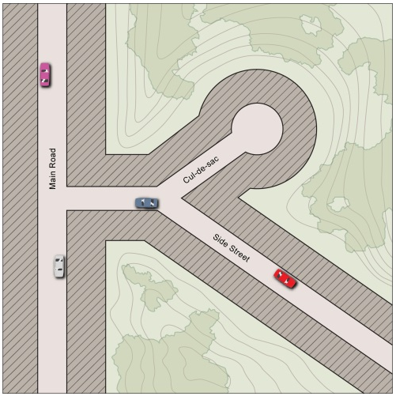  Figure 8.2.3-2a  Unacceptable design – along a ridge top in a bushfire hazard area – the ridge top development has no fire control lines and obstructs fire fighters. | 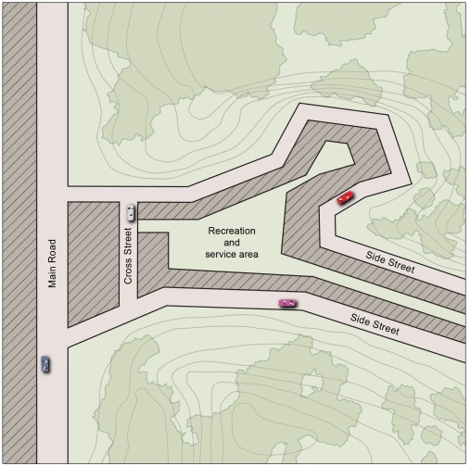  Figure 8.2.3-2b  Acceptable design – Ring road system provides a fire control line and access for fire fighters with all lots located on the inside of the ring-road.
Clearing
po7  In a bushfire hazard area, the development layout is designed to avoid the requirement to clear vegetation to achieve risk reduction. | AO7  The Bushfire management plan details the required extent of vegetation clearing and landscaping and where required modify development design and/or lot layout to minimise clearing of vegetation.  Note: For guidance on how to prepare a Bushfire management plan refer to SC6.3 City Plan Policy – Bushfire management plans. | COMPLIES
Open space management plan
PO8  For areas to be dedicated to Council as open space, management strategies to mitigate bushfire risk must be identified. | AO8  The Bushfire management plan contains a separate section detailing management strategies for areas to be dedicated to Council that can be included within the Open space management plan.  Note: For guidance on how to prepare a Bushfire management plan refer to SC6.3 City Plan Policy – Bushfire management plans. | n/a
Fire trails
PO9  In a bushfire hazard area, fire trails must be provided to:  (a) enable access for fire fighters, residents and equipment;  (b) contribute to (where required) bushfire radiation zone(s);  (c) mitigate against bushfire hazard; and  (d) allow access for hazard reduction management programs.  Note: fire trails should be located, constructed and maintained with due regard for landscape and ecological values and should not result in soil disturbance or erosion. | AO9.1  Fire trails are located on public land (including public open space areas) to facilitate access for fire brigades.  OR  Fire trails located on private property are located as close as possible to the property boundaries and the adjoining bushfire hazard area, and an access easement is granted in favour of City of Gold Coast and Queensland Fire and Emergency Services.  Note: Design and construction of all fire trails located on land to be dedicated to the City as Conservation Estate are in accordance with SC6.3 City Plan policy – Bushfire management plans, Section 3.5(f). For other fire trails, AO9.2 – AO9.6 apply. | n/a
 | AO9.2  The fire trail has:  (a) a minimum cleared width of 6m;  (b) a minimum of 4.8m vertical clearance;  (c) a cross fall of no greater than 10 degrees;  (d) a minimum formed width of 4m;  (e) a maximum gradient of 12.5%, with adequate drainage to prevent soil erosion and minimise ongoing trail maintenance; and  (f) culverts and/or bridges with a minimum load bearing of 8 tonnes (if applicable). | n/a
 | AO9.3  Vehicular links are provided along the fire trail either to existing fire trails or roads, and these links are designed having regard to the topography of the site, fire fighter safety and the need to regularly access water supplies.  Note: where possible, these links should be at intervals of approximately 200m | n/a
 | AO9.4  The fire trail has vehicular access at each end, and links either to existing fire trails or public roads. | n/a
 | AO9.5  The fire trail provides turning areas for fire-fighting appliances. The turning bay can be either:  (a) a turning circle;  (b) a ‘T’ shaped turning bay; or  (c) a ‘Y’ shaped turning bay. | n/a
 | AO9.6  The fire trail provides areas for vehicles to pass or turn at intervals of not more than 200m and with a maximum grade of 5% (1 in 20). | n/a
Areas with water reticulation
PO10  In a bushfire hazard area, the development maintains the safety of people and property by ensuring that the water supply is reliable and has sufficient flow and pressure requirements for fire-fighting purposes at all times. | AO10.1  The development is proposed in a bushfire hazard area, and reticulated water is supplied in accordance with SC6.11 City Plan policy – Land development guidelines, Section 6 – Water supply and sewerage reticulation standards. | COMPLIES
 | AO10.2  Development involving new or existing buildings with a gross floor area of greater than 50m², each lot has a reliable reticulated water supply that has sufficient flow and pressure characteristics for fire-fighting purposes at all times. It must have a minimum pressure and flow of 10 litres a second at 200 kPa. | n/a
Areas with no water reticulation (private water supply)
po11  In a bushfire hazard area, the development maintains the safety of people and property by ensuring that an adequate water supply for fire-fighting purposes is provided. | AO11.1  For development with a combined GFA less than 500m² where one or more buildings are proposed, dedicated fire-fighting water storage is provided to protect each individual building. Each dedicated fire-fighting water storage must have a volume of water not less than 10,000 litres for each building, be provided within 10m of each building and be:  (a) a separate tank that is either below ground level or of non -flammable construction; or  (b) a reserve section in the bottom part of the main water supply tank that is either below ground level or of non -flammable construction.  Note: dedicated fire-fighting water storage is in addition to water supply for household use and does not include swimming pools, creeks and dams. | n/a
 | AO11.2  For development that proposes one or more buildings with a combined GFA greater than 500m² there is no acceptable outcome provided. | n/a
PO12  In a bushfire hazard area, all fire-fighting water storage tanks, including domestic water supply tanks, are fitted with the standard rural fire brigade fittings. | AO12  The outlet pipe is 50mm in diameter, fitted with a 50mm male camlock (standard rural fire brigade fitting) and an isolating valve. | n/a
po13  In a bushfire hazard area, water storage provided for fire-fighting purposes is safely located and accessible at all times. | AO13.1  The water supply outlet is located at least 9m from any potential fire hazards, such as venting gas bottles and combustible structures. | COMPLIES
 | AO13.2  A safe and accessible hard stand area capable of accommodating a fire fighting vehicle is provided not more than 3m from the water supply outlet. | COMPLIES
PO14  Development in a bushfire hazard area must provide adequate fire-fighting water storage. This infrastructure must be provided on public land so as to be readily accessible to fire brigades for hazard reduction and fire-fighting purposes. | AO14.1  Where public water supplies (e.g. fire hydrants or public water storage) do not exist, water supply tanks are provided for fire-fighting purposes on public land within the development. The water tanks must:  (a) Be installed on land dedicated to Council;  (b) hold a volume of at least 22,500 litres per every 20 dwellings;  (c) be of concrete construction; and  (d) have an outlet pipe of 50mm in diameter, fitted with a 50mm male camlock (standard rural fire brigade fitting) and an isolating valve. | will comply
 | AO14.2  Development on public land provides a safe and accessible hardstand area capable of accommodating a fire fighting vehicle not more than 3m from the water supply outlet. | n/a
Storage of Hazardous Materials
PO15  Development does not cause:  (a) an unacceptable risk to people, property and the environment due to the impact of bushfire on hazardous chemicals;  (b) excess danger or difficulty to emergency services for emergency response or evacuation. | AO15  Development involving the storage, handling or manufacture of hazardous chemicals is not located within a Bushfire hazard area. | n/a
Advice to new residents
PO16  In a bushfire hazard area, new residents/occupants of a development in a bushfire hazard area are informed about:  (a) the potential bushfire hazard on their site;  (b) their responsibility for fire management;  (c) the measures required for ongoing fire hazard mitigation; and  (d) emergency procedures during a bushfire or on bad fire weather days.  Editor’s note - Further information on bushfire preparation can be found at www.ruralfire.qld.gov.au | AO16  A copy of the Bushfire management plan, complete with the Queensland Fire and Emergency Services cover sheet and any other addendums is provided to each resident/occupant for their information.  Note: the QFES cover sheet is attached to the approved Bushfire management plan and a notification will be placed on the property’s rates notice. | COMPLIES

City Plan code template
This code template supports the preparation of a development application against either the acceptable outcome(s) or performance outcome(s) contained in the code. Development assessment rules are outlined in Section 5.3.3 of the City Plan.
Please note:
For assessment against the overall outcomes, refer to the appropriate code.
Note: The whole of the planning scheme is identified as the assessment benchmark for impact assessable development. This specifically includes assessment of impact assessable development against this strategic framework. The strategic framework may contain intentions and requirements that are additional to and not necessarily repeated in zone, overlay or other codes. In particular, the performance outcomes in zone codes address only a limited number of aspects, predominantly related to built form. Development that is impact assessable must also be assessed against the overall outcomes of the code as well as the strategic framework.
Environmental significance overlay code
      - Application
This code applies to assessing all material change of use, reconfiguration of a lot and operational works (vegetation clearing, changes to ground level, infrastructure) for development on land identified in Part 5.10 Categories of development and assessment and containing the following mapped areas:
Overlay map | Mapped area
Environmental significance – biodiversity areas | Matters of State environmental significance  • Protected Areas  Matters of Local environmental significance  • Hinterland core habitat system;  • Coastal wetlands and islands core habitat system;  • Substantial remnants; and  • Hinterland to coast critical corridors.
Environmental significance – priority species | Matters of State environmental significance  • Koala habitat areas; and  • State significant species.  Matters of Local environmental significance  • Local significant species.
Environmental significance – vegetation management | Matters of State environmental significance  • Regulated Vegetation.  Matters of Local environmental significance  • High priority vegetation;  • Medium priority vegetation; and  • General priority vegetation.
Environmental significance – wetlands and waterways | Matters of State environmental significance  • State significant aquatic systems; and  • State significant wetlands.  Matters of Local environmental significance  • Major waterway;  • Waterway; and  Local significant wetlands.
When using this code, reference should be made to Section 5.3.2 and, where applicable, Section 5.3.3, in Part 5.
Note: Buffers are taken as the maximum distance applicable for the site and are not cumulative.

8.2.6.2 Purpose
(1) The purpose of the Environmental significance overlay code is to identify and protect matters of environmental significance and ensure that development is consistent with, and contributes to, the achievement of the objectives of the Our Natural City Strategy.
(2) The purpose of the code will be achieved through the following overall outcomes:
(a) Matters of environmental significance are identified, protected in situ and enhanced to maintain flora and fauna diversity within:
(i) Hinterland core habitat systems;
(ii) Coastal wetlands and islands core habitat systems;
(iii) Substantial remnants; and
(iv) Hinterland to coast critical corridors.
(b) Degraded matters of environmental significance are protected and rehabilitated.
(c) High priority vegetation is protected in situ.
(d) Outside of Biodiversity Areas:
(i) Disturbance to regulated and general priority vegetation is minimised;
(ii) Impacts on medium priority vegetation are managed, in order of priority, by:
(A) avoiding significant adverse impacts;
(B) mitigating significant adverse impacts where these cannot be avoided; and
(C) offsetting any significant residual impacts.
(iii) State and local significant species and their habitat are identified and protected.
(iv) The quality or connectivity of habitat for State and local significant species (including the koala) is improved.
(e) Wetlands, waterways and their associated buffers (as prescribed in RO2) are protected and enhanced.
(f) Buffers are provided between matters of environmental significance and any proposed development, to manage impacts.
(g) Appropriate tenure and management arrangements are provided to protect matters of environmental significance and their associated buffers.
(h) Where offsets are required, these are consistent with the Environmental Offsets Act 2014.
(i) Management strategies and appropriate clearing practices are implemented to ensure any fauna impacted by development activities are managed and protected during works.
Editor’s Note – in addition to the requirements of this planning scheme, obligations for the protection of matters of environmental significance are established by the Commonwealth and Queensland Government. Additional approvals or referrals may be required.

8.2.6.3 Specific benchmarks for assessment
Table 8.2.6-2: Environmental significance overlay code – for assessable development
Performance outcomes | Acceptable outcomes | Does the proposal meet the acceptable outcome?  If not, justify how the proposal meets either the performance outcome or overall outcome | Internal use
Ecological site assessment
po1  All matters of environmental significance on and adjacent to the development site are identified and protected.  Note - An Ecological Site Assessment prepared in accordance with SC6.7 City Plan policy – Ecological site assessments, is Council’s preferred method for addressing this performance outcome. | AO1  Proposed works do not impact on:  - areas identified on Environmental significance – vegetation management overlay map;  - buffers to wetlands and waterways being:  - 100m from the mapped boundary of a State significant aquatic area, as identified on Environmental significance – wetlands and waterways overlay map;  - 100m from the outer landward boundary of a State significant wetland, as identified on Environmental significance – wetlands and waterways overlay map;  - 100m from the outer landward boundary of a Local significant wetland, as identified on Environmental significance – wetlands and waterways overlay map;  - 60m from the outer bank of a Major Waterway identified on Environmental significance – wetlands and waterways overlay map; or  - 30m from the outer bank of a Waterway identified on Environmental significance – wetlands and waterways overlay map; and  - individual trees within areas mapped on the Environmental significance – priority species overlay map. | cOMPLIES WITH AO1
Biodiversity areas
po2  Development does not impact on Protected Areas as identified on the Environmental significance–biodiversity areas overlay map. | - AO2.1  - No acceptable outcome provided. | - Complies with PO2.
po3  Development within the Hinterland to Coast Critical Corridors as identified on the Environmental significance –biodiversity areas overlay map is located and designed to:  - provide corridors of sufficient dimensions and characteristics that will enable adequate movement of fauna through the site;  - protect in situ matters of environmental significance and associated buffers;  - protect in situ, vegetation identified on the Environmental significance – vegetation management overlay map and habitat for native flora and fauna;  - link matters of environmental significance, existing corridors and/or conservation estate/reserves on adjacent properties;  - maintain and improve upon the regional connectivity of the Hinterland to Coast Critical Corridors; and  - allow for the rehabilitation of disturbed, cleared or modified areas that form part of the Hinterland to Coast Critical Corridors.  Note: Recommendations provided in an ecological site assessment (prepared in accordance with SC6.7 City Plan policy – Ecological site assessments) are Council’s preferred method for determining corridor dimensions. | AO3.1  - No acceptable outcome provided. | Complies with PO3.
po4  Development within Hinterland Core Habitat Systems, Coastal Wetlands and Islands Core Habitat Systems and Substantial Remnant Areas as identified on the Environmental significance – biodiversity areas overlay map is located and designed to:  - protect in situ matters of environmental significance and associated buffers;  - protect in situ vegetation identified on the Environmental significance – vegetation management overlay map and habitat for native flora and fauna; and  - allow for the rehabilitation of disturbed, cleared or modified areas. | AO4  No acceptable outcome provided. | Complies with PO4.
Wetland and waterway
po5  Buffers are provided to wetlands and waterways identified on the Environmental significance – wetlands and waterways overlay map to ensure the:  - protection of matters of environmental significance mapped onsite or identified through an ecological site assessment;  - unimpeded movement of fauna along the waterway;  - water quality is maintained;  - bank stability; and  - protection of property and infrastructure.  Note: The buffer width for wetlands is measured from the outer, landward boundary of the mapped wetland, as shown on Environmental significance – wetlands and waterways overlay map.  Note: Recommendations provided in an ecological site assessment (prepared in accordance with SC6.7 City Plan policy – Ecological site assessments) is Council’s preferred method for determining alternative buffer widths.  Note Artificial waterways are to be addressed through the Coastal erosion hazard overlay code and map. Where a waterbody contains both natural and artificial banks, the natural banks are to be assessed in accordance with this performance outcome. | AO5.1  Buffers at least 100m wide are provided between the development and the mapped boundary of a State significant aquatic area, as identified on Environmental significance – wetlands and waterways overlay map. | N/A
 | AO5.2  Buffers at least 100m wide are provided between the development and the outer landward boundary of a State significant wetland, as identified on Environmental significance – wetlands and waterways overlay map. | N/A
 | AO5.3  Buffers at least 100m wide are provided between the development and the outer landward boundary of a Local significant wetland as identified on the Environmental significance – wetlands and waterways overlay map. | N/A
 | AO5.4  Buffers at least 60m wide are provided between the development and the outer bank of a Major Waterway as identified on the Environmental significance – wetlands and waterways overlay map. | COMPLIES
 | AO5.5  Buffers at least 30m wide are provided between the development and the outer bank of a waterway as identified on the Environmental significance – wetlands and waterways overlay map. | COMPLIES
Vegetation management
PO6  Regulated vegetation is protected in situ when it is:  - identified on the Environmental significance – vegetation management overlay map; and  - within biodiversity areas as identified on the Environmental significance – biodiversity areas overlay map. | AO6  Development does not impact on regulated vegetation. | Complies with ao6.
PO7  Development is designed to maintain regulated vegetation and minimise disturbance when it is:  - identified on the Environmental significance – vegetation management overlay map; and  - outside of biodiversity areas as identified on the Environmental significance – biodiversity areas overlay map. | AO7  Development avoids impacts on regulated vegetation. | complies with ao7.
PO8  High priority vegetation as identified on the Environmental significance – vegetation management overlay map is protected in situ. | AO8  No acceptable outcome provided. | COMPLIES
PO9  Medium and general priority vegetation as identified on the Environmental significance – vegetation management overlay map within biodiversity areas as identified on the Environmental significance –biodiversity areas overlay map is protected in situ. | AO9  No acceptable outcome provided. | COMPLIES
PO10  Vegetation is protected when it is:  - identified as medium priority vegetation on the Environmental significance – vegetation management overlay map; and  - located outside the biodiversity areas identified on the Environmental significance – biodiversity areas overlay map. | AO10  Vegetation is not damaged when it is:  - identified as medium priority vegetation on the Environmental significance – vegetation management overlay map; and  - located outside the Environmental significance –biodiversity areas overlay map.  OR  Where all attempts have been made to avoid and minimise damage to vegetation as stated above, any significant residual impact is offset consistent with the Environmental Offsets Act 2014, at a ratio of 3:1 (area) in accordance with SC6.9 City Plan policy – Environmental offsets.  OR  Damage to medium priority vegetation identified on the Environmental significance – vegetation management overlay map and located outside the biodiversity areas identified on the Environmental significance – biodiversity areas overlay map is for committed development. | COMPLIES
PO11  Disturbance to vegetation is minimised when it is:  - identified as General priority vegetation on the Environmental significance – vegetation management overlay map; and  - located outside the Environmental significance – biodiversity areas overlay map. | AO11  Development avoids impacts on general priority vegetation. Any damage is minimised to the greatest extent possible. | COMPLIES
po12  Buffers are provided that protect the long term viability of high priority and regulated vegetation located on or adjacent to the site. | AO12  Buffers at least 30m wide are provided between the development and any retained vegetation identified as high priority or regulated vegetation on the Environmental significance – vegetation management overlay map on or adjacent to the site. | COMPLIES
Priority species
Po13  Assessable koala feed and shelter trees are protected in situ when they are located:  - in koala habitat areas as identified on the Environmental significance – priority species overlay map; and  - within biodiversity areas as identified on the Environmental significance – biodiversity areas overlay map. | AO13  Development does not impact on assessable koala feed and shelter trees. | complies with ao13.
PO14  Assessable koala feed and shelter trees are protected when they are:  - in koala habitat areas as identified on the Environmental significance – priority species overlay map; and  - outside biodiversity areas as identified on the Environmental significance – biodiversity areas overlay map. | AO14  Development avoids impacts on assessable koala feed and shelter trees. Any damage is minimised to the greatest extent possible. | complies with ao14.
PO15  Site design provides safe koala movement opportunities by incorporating measures to maintain connectivity between areas of koala habitat on and adjacent to the site.  Note : DEHP’s Koala-Sensitive Design Guideline should be consulted for suitable measures to provide for safe koala movement. | AO15  No acceptable outcome provided. | complies with po15.
PO16  During the clearing and construction phases, measures are incorporated to protect koalas from death or injury. | AO16  Threats to koalas as a result of clearing and construction activities are mitigated by:  - ensuring no tree in which a koala is present or a tree with a crown overlapping a tree containing a koala is cleared;  - undertaking clearing of vegetation in stages, and ensuring:  - no more than 1 ha is cleared per day for sites less than 6 ha in size;  - no more than 2 ha is cleared per day for sites greater than 6 ha in size;  - that between each stage there is at least 12 hours where no clearing occurs; and  - koala habitat is always linked to allow koalas to move out of the site;  - use of qualified koala spotters;  - prohibition of domestic dogs and security dogs on site; and  - use of koala safety fencing. | N/A
PO17  State significant species, and their habitat, are protected in situ when it is:  - identified on the Environmental significance – priority species overlay map, or through an ecological site assessment; and  - within biodiversity areas as identified on the Environmental significance – biodiversity areas overlay map. | AO17  Development does not impact on State significant species, and their habitat. | COMPLIES
PO18  Development protects state significant species, and their habitat or is designed to minimise and mitigate impacts on habitat values when it is:  - identified on the Environmental significance – priority species overlay map; and  - outside of biodiversity areas as identified on the Environmental significance – biodiversity areas overlay map. | AO18.1  Development avoids impacts on state significant species, and their habitat. | COMPLIES
AO18.2
Where development impacts on state significant species and their habitat, the following occurs:
- flora species are propagated and used in rehabilitation and landscaping onsite; and
- fauna species are safely relocated by a qualified fauna spotter catcher.
PO19  Local significant species, and their habitat, are protected in situ when it is:  - identified on the Environmental significance – priority species overlay map, or through an ecological site assessment; and  - within biodiversity areas as identified on the Environmental significance – biodiversity areas overlay map. | AO19  Development does not impact on local significant species, and their habitat. | complies with ao19
PO20  Development protects local significant species, and their habitat or is designed to minimise and mitigate impacts on habitat values when it is:  - identified on the Environmental significance – priority species overlay map; and  - outside of biodiversity areas as identified on the Environmental significance – biodiversity areas overlay map. | AO20.1  Development avoids impacts on local significant species, and their habitat. | complies with ao20.1
 | AO20.2  Where development impacts on local significant species and their habitat, the following occurs:  - flora species are propagated and used in rehabilitation and landscaping onsite; and  - fauna species are safely relocated by a qualified fauna spotter catcher. | complies with ao20.2
Fauna management
PO21  Development design and location provides for the safe movement of native fauna through the site. | AO21  Where infrastructure crosses native fauna movement paths, the design of new development incorporates fauna friendly movement solutions.  Note: Fauna friendly movement solutions developed in accordance with the Queensland Government Fauna Sensitive Road Design Manual Volume 2: Preferred Practices; and the QLD Government Koala-Sensitive Design Guidelines is Council’s preferred method for addressing this outcome. | N/A
PO22  Where fauna habitat is proposed to be damaged, management strategies must be implemented to ensure:  - the native fauna is safely relocated to an area of similar habitat;  - the sequence of habitat disturbance ensures that fauna is not isolated from adjoining areas of habitat;  - fauna relocation occurs immediately prior to habitat disturbance;  - accredited and experienced spotter catchers, licensed by the Queensland Parks and Wildlife Service, are to be present on the site to direct and undertake the removal and relocation of fauna; and  - where possible, damaged habitat and nesting sites are rehabilitated outside of development areas.  Note: A Fauna Management Plan prepared by a suitably qualified person and in accordance with SC6.8 City Plan policy – Environmental management plans is Council's preferred method for addressing this outcome. | AO22  No acceptable outcome provided. | N/A
Tenure, ownership and management arrangements
PO23  Matters of environmental significance and associated buffers, mapped areas as identified on the Environmental significance – vegetation management overlay map proposed for retention and areas requiring rehabilitation are suitably protected in perpetuity and will:  - enable necessary fire management in accordance with an approved fire management plan and any adopted bushfire management plan;  - allow unimpeded movement of native fauna through matters of environmental significance and associated buffers;  - enable maintenance access and regular management;  - enable auditing and reporting of maintenance and management activities;  - provide for public access along major waterways, where such access is consistent with the ecological functions;  - allow for linkages and buffers to adjacent areas of ecological significance; and  - allow for a coordinated approach to the management of adjacent areas of conservation estate. | AO23  Matters of environmental significance and associated buffers, mapped areas as identified on the Environmental significance – vegetation management overlay map proposed for retention and areas requiring rehabilitation are transferred to Council ownership as Public Open Space.  OR  Where not required for public access, matters of environmental significance and associated buffers, and mapped areas as identified on the Environmental significance – vegetation management overlay map proposed for retention and areas requiring rehabilitation are retained in private ownership and protected under a statutory covenant (under the Land Title Act 1994).  Note: Where the area is adjacent to existing public open space, or is a buffer to a major waterway, Council's preference is for the land to be dedicated as Public Open Space. | N/A
PO24  An Open Space Management Plan prepared in accordance with SC6.12 City Plan policy – Landscape work is prepared for areas to be dedicated to Council as Public Open Space. | AO24  No acceptable outcome provided.
PO25  A Covenant Management Plan is prepared for areas to be protected under a statutory covenant. The management plan must include the following details:  - rehabilitation area and strategy of works;  - weed eradication and control requirements;  - how the covenant area will be maintained and managed in perpetuity;  - feral and domestic animal exclusion requirements; and  - required maintenance access.  Note: A Covenant Management Plan is prepared by a suitably qualified person and in accordance with SC6.8 City Plan policy – Environmental management plans is Council’s preferred method for addressing this performance outcome. | AO25  No acceptable outcome provided. | N/A
Rehabilitation
PO26  Disturbed, cleared or modified areas are rehabilitated where they form part of:  - an ecological corridor; or  - matters of environmental significance and associated buffers; or  - areas identified within an Ecological Site Assessment as requiring rehabilitation.  Note: A Rehabilitation Management Plan prepared in accordance with the South East Queensland Ecological Restoration Framework and SC6.8 City Plan policy – Environmental management plans is Council's preferred method for addressing this outcome. | AO26  No acceptable outcome provided. | N/A

City Plan code template
This code template supports the preparation of a development application against either the acceptable outcome(s) or performance outcome(s) contained in the code. Development assessment rules are outlined in Section 5.3.3 of the City Plan.
Please note:
For assessment against the overall outcomes, refer to the appropriate code.
Note: The whole of the planning scheme is identified as the assessment benchmark for impact assessable development. This specifically includes assessment of impact assessable development against this strategic framework. The strategic framework may contain intentions and requirements that are additional to and not necessarily repeated in zone, overlay or other codes. In particular, the performance outcomes in zone codes address only a limited number of aspects, predominantly related to built form. Development that is impact assessable must also be assessed against the overall outcomes of the code as well as the strategic framework.
    - Landslide hazard overlay code
      - Application
This code applies to assessing material change of use, reconfiguring a lot or operational work for development located on any lot partially or completely subject to the Landslide hazard overlay and identified within Part 5.10 Categories of development and assessment – Overlays.
When using this code, reference should be made to Section 5.3.2 and, where applicable, Section 5.3.3, in Part 5.

8.2.11.2 Purpose
(1) The Landslide hazard overlay code deals with areas of land identified in the local government area as having landslide potential. It applies, at a minimum, to development that:
(a) increases the number of people living and working in the natural hazard management area, except where the premises are occupied on a short term or intermittent basis; or
(b) involves institutional uses where evacuating people may be difficult; or
(c) involves the manufacture or storage of hazardous materials in bulk.
(2) The purpose of the Landslide hazard overlay code is to regulate development which occurs on land or part of any land containing steep slopes or unstable slopes.
(3) The purpose of the code will be achieved through the following overall outcomes:
- The potential for erosion or landslide is minimised.
- The risk of landslides damaging property or endangering persons is minimised.
- Stormwater runoff and waste water disposal is effectively managed so that it does not increase landslide risk on the site or neighbouring sites.
- Erosion events on slopes exceeding an average gradient of 20% are minimised.
- Safe and efficient vehicular access onto steeply sloping land is provided.
- Development does not occur at the expense of other environmental values.

      - Specific benchmarks for assessment
Table 8.2.11-2: Landslide hazard overlay code – for assessable development
Performance outcomes | Acceptable outcomes
Site slope constraints
po1  Development must be certified by an RPEQ as being responsive to the constraints of steeply sloping land.  Note: For guidance on how to meet this performance outcome, refer to SC6.10 City Plan policy – Geotechnical stability assessment guideline. | AO1  Development is not to be undertaken on any lot partially or completely identified on the Landslide hazard overlay map, unless certification is provided by an RPEQ, confirming that the proposed development is appropriate for the sloping nature of the site, and that the risk of landslide adversely affecting the subject lot, adjoining properties and the proposed development is at a low level. | COMPLIES- The new lot and building envelope will not be within the zone.
Stormwater drainage
po2  Development must ensure that stormwater runoff does not increase the susceptibility of the site to landslide and does not cause any detriment to the natural environment or to any other lots. | AO2.1  Stormwater drainage (including roof guttering and rainwater tank overflows) is managed to avoid an increase in on-site groundwater, ponding of water and water concentration into slopes and discharges to a lawful point of discharge. | will comply
 | AO2.2  Stormwater drainage is in accordance with SC6.11 City Plan policy – Land development guidelines, Section 4 – Stormwater drainage and water sensitive urban design. | will comply
Cut and fill work
Po3  Cut and fill work must not adversely affect slope stability or create erosion potential. | AO3.1  Cuts and fills should be minimised. The height of cut and/or fill, whether retained or not, does not exceed:  (a) 900mm adjoining a public area (e.g. roads, public open space areas);  (b) 1200mm adjoining a residential site;  (c) 2500mm adjoining a non-residential site.  OR  Cuts greater than 900mm height are separated by terraces with a minimum width of 1.2m or equal to the height of the cut, whichever is greater, that incorporates drainage provisions in accordance with Council’s SC6.11 City Plan policy – Land development guidelines, Section 3 – Change to ground level standards and Section 4 – Stormwater drainage and water sensitive urban design. | n/a
 | AO3.2  No crest of any cut or toe of any fill, or any part of any retaining wall or structure, is located closer than 600mm to any boundary of the lot, unless the prior approval of both landowners and the Council, or its delegate, has been obtained. | n/a
 | AO3.3  Cut and/or fill on slopes steeper than 1V:2H (26º) are retained at the time of earthworks by retaining structures or other stabilisation methods, in accordance with SC6.11 City Plan policy – Land development guidelines, Section 3 – Change to ground level standards. | n/a
 | AO3.4  All retaining walls on lots identified on the Landslide hazard overlay map are designed and certified by an RPEQ as not adversely affecting the site’s overall stability. Boulder walls must not be used as retaining walls on sites steeper than 20%. | n/a
 | AO3.5  Non-retained cut and/or fill on slopes are stabilised and protected against scour and erosion by suitable measures, such as grassing, dense landscaping or other protective measures, in accordance with SC6.11 City Plan policy – Land development guidelines, Section 3 – Change to ground level standards. | n/a
Wastewater
PO4  Wastewater disposal must not create or increase the likelihood of instability on the site or neighbouring sites. | AO4  All wastewater is disposed of via connection to sewerage reticulation.  OR  Where sewerage reticulation is not available on site, effluent disposal areas are located so as to not cause potential instability. Subsurface disposal of effluent is not to be used. | COMPLIES
Slope constraints and stability
Po5  Development on any lot partially or completely mapped as moderate, high or very high landslide hazard, as identified on the Landslide hazard overlay map, is supported by an RPEQ certified geotechnical report, which adequately assesses and documents the site’s geotechnical stability and constraints, and incorporates necessary mitigation measures so that the level of landslide risk to property and persons is low.  Note: A geotechnical stability assessment report prepared in accordance with SC6.10 City Plan policy – Geotechnical stability assessment guidelines is Council’s preferred method for addressing this performance outcome. | AO5  A geotechnical stability assessment report, which is prepared and certified by an RPEQ, includes:  (a) the following information:  (i) boundary dimensions;  (ii) location of easements;  (iii) existing and proposed services, such as sewer, stormwater, gas, electricity, telephone, and other utility services;  (iv) contour lines to AHD (500mm vertical intervals);  (v) street front kerb locations, crossovers, side gully pit locations, driveway locations and slope;  (vi) off-street parking locations, building locations and setback dimensions;  (vii) earthwork details and building pad levels;  (viii) retaining wall locations, type, extent, height, and offset from boundaries;  (ix) existing and proposed onsite drainage systems;  (x) identification of trees to be removed or retained;  (xi) fencing extent, location, height and depth;  (xii) swimming pool location, level and depth;  (xiii) ancillary structures, such as pergolas and sheds;  (xiv) landscaping, lawn areas, paved areas, mass planting areas and trees;  (xv) slope angles;  (xvi) slope shape and features;  (xvii) parent rock type/soil type;  (xviii) engineering properties of sub-surface materials;  (xix) concentration of surface water;  (xx) concentration of ground water;  (xxi) evidence of instability on the site and adjoining areas;  (xxii) history of instability on the site and adjoining areas; and  (xxiii) geotechnical model of the site.  (b) a site-specific landslip susceptibility frequency analysis, including analysis of each proposed lot;  (c) if the outcome of the landslip susceptibility frequency analysis is moderate or higher, a risk assessment in accordance with the AGS Landslide Risk Management 2007 Guidelines;  (d) an assessment of the suitability of the site for the proposed development having regard to (a) – (c);  (e) a foundation investigation report that determines the site classification for the lot/each proposed lot in accordance with AS 2870-2011 Residential slabs and footings and provides recommendations for foundation design;  (f) identification of any areas on the lot/within proposed lots where development must not occur;  (g) certification from the RPEQ confirming that the site (and for subdivisions, each proposed lot) achieves a landslide risk rating of ‘low’ or better and the site/lot is suitable for its intended use; and  (h) recommendations for any necessary mitigation measures, construction measures and design changes to be implemented to ensure the stability of the site and adjoining areas is not adversely affected and to ensure long-term stability of the site. | N/A
Access (for subdivision only)
PO6  Development on steep slopes must ensure that safe and efficient access by vehicles and pedestrians can be achieved. | AO6  The building envelope within every lot is accessible by a legal road access, in compliance with SC6.11 City Plan policy – Land development guidelines, Section 2 – Transport network standards. | COMPLES

Environmental values
po7  Works to mitigate landslide risks avoid adverse impact on other environmental values. | AO7  No acceptable outcome is provided. | COMPLIES

City Plan code template
This code template supports the preparation of a development application against either the acceptable outcome(s) or performance outcome(s) contained in the code. Development assessment rules are outlined in Section 5.3.3 of the City Plan.
Please note:
For assessment against the overall outcomes, refer to the appropriate code.
Note: The whole of the planning scheme is identified as the assessment benchmark for impact assessable development. This specifically includes assessment of impact assessable development against this strategic framework. The strategic framework may contain intentions and requirements that are additional to and not necessarily repeated in zone, overlay or other codes. In particular, the performance outcomes in zone codes address only a limited number of aspects, predominantly related to built form. Development that is impact assessable must also be assessed against the overall outcomes of the code as well as the strategic framework.
    - On-site sewerage facilities code

9.4.7.1 Application
This code applies to assessing material change of use for development on land not serviced by sewer infrastructure where indicated within Part 5 Tables of assessment.
When using this code, reference should be made to Section 5.3.2 and, where applicable, Section 5.3.3, in Part 5.

9.4.7.2 Purpose
(1) The purpose of the On-site sewerage facilities code is to ensure that on-site sewerage facilities do not cause any environmental harm or health risk.
(2) The purpose of the code will be achieved through the following overall outcome:
(a) On-site sewerage facilities are appropriately designed and located for wastewater disposal.

9.4.7.3 Specific benchmarks for assessment
Table 9.4.7-1: On-site sewerage facilities code – for assessable development
Performance outcomes | Acceptable outcomes | Does the proposal meet the acceptable outcome?  If not, justify how the proposal meets either the performance outcome or overall outcome | Internal use
Design and siting
po1  Development on land not serviced by sewer infrastructure has a suitable on-site wastewater disposal area that complies with:  - Queensland Plumbing and Wastewater Code;  - AS/NZS 1547:2012 – On-site domestic wastewater management; and  - AS/NZ 1546.1:2008 On-site domestic wastewater treatment units – Part 1: Septic tanks, AS/NZS 1546.2:2008 On-site domestic wastewater treatment units Part 2: Waterless composting toilets and AS/NZS 1546.3:2008 On-site domestic wastewater treatment units – Part 3: Aerated wastewater treatment systems.  Editor’s note: an Effluent Disposal Report prepared by a Council registered person is Council’s preferred method of addressing the above outcome. | AO1  No acceptable outcome provided. | COMPLIES
po2  The on-site sewerage facility is provided on the same lot as the proposed development. | AO2  No acceptable outcome provided. | COMPLIES

City Plan code template
This code template supports the preparation of a development application against either the acceptable outcome(s) or performance outcome(s) contained in the code. Development assessment rules are outlined in Section 5.3.3 of the City Plan.
Please note:
For assessment against the overall outcomes, refer to the appropriate code.
Note: The whole of the planning scheme is identified as the assessment benchmark for impact assessable development. This specifically includes assessment of impact assessable development against this strategic framework. The strategic framework may contain intentions and requirements that are additional to and not necessarily repeated in zone, overlay or other codes. In particular, the performance outcomes in zone codes address only a limited number of aspects, predominantly related to built form. Development that is impact assessable must also be assessed against the overall outcomes of the code as well as the strategic framework.
    - Vegetation management code
      - Application
This code applies to assessing material change of use, reconfiguring a lot or operational work for development where indicated within Part 5 Tables of assessment.
When using this code, reference should be made to Section 5.3.2 and, where applicable, Section 5.3.3, in Part 5.
The requirements for accepted development in Part A of this code provide guidance on what is considered acceptable damage to assessable vegetation before it becomes assessable development. Each required outcome in Part A will apply to a particular circumstance. The table below outlines the applicable provision relating to the type of damage.
Damage type | Provision(s)
Vegetation close to property boundaries | RO1 – RO2
Vegetation close to buildings | RO3
Vegetation close to pool fencing | RO4
Pest species vegetation | RO5
Threatening vegetation | RO6
Damage to vegetation for fire safety | RO7
Damage on agricultural land | RO8
Vegetation maintenance | RO9
All damage not described in the required outcomes | PO1
Note: The required outcomes in Part A of this code will not apply to vegetation that is identified under a vegetation protection order or planted as an approved landscape plan or condition of approval.
Note: For general guidance on pruning and managing the growth of vegetation refer toAS4373–2007 Pruning of amenity trees.
Note: Vegetation clearing must not result in harm to native wildlife. Where native wildlife is present it is recommended that a licensed wildlife spotter catcher be employed to oversee works.

9.4.14.2 Purpose
(1) The purpose of the Vegetation management code is to provide for the protection and management of assessable vegetation.
(2) The purpose of the code will be achieved through the following overall outcomes:
(a) Vegetation of environmental, historical, cultural, visual and character significance is retained.
(b) Vegetation is retained to provide habitats for threatened flora and fauna, prevent erosion and ensure slope stabilisation.
(c) Damage to assessable vegetation is only undertaken if it directly obstructs approved development or is a threat to persons or property.
(d) Vegetation management plans are prepared for development which has the potential to cause damage to vegetation.
(e) Any potential damage caused to vegetation by development is extensively investigated and mitigated.

9.4.14.3 Specific benchmarks for assessment
Table 9.4.14-2: Vegetation management code – for assessable development
Performance outcomes | Acceptable outcomes | Does the proposal meet the acceptable outcome?  If not, justify how the proposal meets either the performance outcome or overall outcome | Internal use
Vegetation management plan
po1  Damage to assessable vegetation does not occur where the vegetation:  - provides habitats for threatened flora and fauna;  - is of historical, cultural or visual significance;  - provides erosion prevention and slope stabilisation;  - is necessary to maintain the character of the local area; or  - assists in the conservation of the city's biodiversity.  Note: A Vegetation Management Plan, prepared in accordance with SC6.8 City Plan policy – Environmental management plans is the Council’s preferred method of addressing this performance outcome. | AO1  A Vegetation Management Plan, prepared by a suitably qualified person, is submitted as part of an Operational Work (Vegetation Clearing) application to show compliance with the Performance outcome. This plan includes, but is not limited to:  - the location of the existing or approved dwellings, building or structures;  - the location of waterways, ridge tops and steep slopes (greater than 25%) on and adjacent to the site;  - the location of the assessable vegetation to which the damage is proposed, and reasonable particulars of its vegetation type, including species, height and girth and whether it is:  - habitat for threatened flora and fauna;  - of historical, cultural, character or visual significance;  - essential for erosion prevention and slope stabilisation, including within waterway buffers;  - significant to the conservation of the city’s biodiversity;  - vegetation that contributes to waterway and wetland health.  - a statement of the reasons for the damage and any relevant factors associated with the purpose of the proposed damage;  - particulars of how vegetation to be retained will be protected during works in accordance with AS4970–2009 Protection of trees on development sites;  - particulars of how the vegetation is to be damaged and, if relevant, how the damaged material is to be removed or disposed of;  - a plan indicating the location, size and species of replacement vegetation to compensate for the loss of damaged vegetation; and  - a staging plan for clearing greater than 4ha of vegetation.  Note: To remove a single tree on residential premises only a basic Vegetation Management Plan is required to be submitted to Council. The Vegetation Management Plan can be prepared by the property owner and may only require limited details about the above elements. Guidance on the content of a Vegetation Management Plan can be found in SC6.8 City Plan policy – Environmental management plans. | COMPLIES

